SELECTION OF CONSULTANTS

REQUEST FOR PROPOSALS

NP-REDD-94160-CS-QCBS

Selection of Consulting Services for: National Forest Inventory Re-measurement of Plots

Client:
Government of Nepal
Ministry of Forests and Environment
REDD Implementation Center, Babarmahal

Country: Nepal

Project: REDD Readiness.

Issued on: 4 February 2019

Preface

This Request for Proposals (“RFP”) has been prepared by the Client and is based on the Standard Request for Proposals (“SRFP”) issued by the World Bank (“the Bank”), dated September 2011.

The SRFP reflects the structure and the provisions of the Master Procurement Document for Selection of Consultants (“Master Document”) prepared by participating Multilateral Development Banks (MDBs), except where specific considerations within the respective institutions have required a change.

TABLE OF CLAUSES

PART I–SELECTION PROCEDURES AND REQUIREMENTS
Section 1. Letter of Invitation 1
Section 2. Instructions to Consultants and Data Sheet 7
A. General Provisions 7
1. Definitions 7
2. Introduction 9
3. Conflict of Interest 9
4. Unfair Competitive Advantage 10
5. Corrupt and Fraudulent Practices 10
6. Eligibility 11
B. Preparation of Proposals 13
7. General Considerations 13
8. Cost of Preparation of Proposal 13
9. Language 13
10. Documents Comprising the Proposal 13
11. Only One Proposal 13
12. Proposal Validity 13
13. Clarification and Amendment of RFP 14
14. Preparation of Proposals – Specific Considerations 15
15. Technical Proposal Format and Content 16
16. Financial Proposal 16
C. Submission, Opening and Evaluation 17
17. Submission, Sealing, and Marking of Proposals 17
18. Confidentiality 18
19. Opening of Technical Proposals 18
20. Proposals Evaluation 19
21. Evaluation of Technical Proposals 19
22. Financial Proposals for QBS 19
23. Public Opening of Financial Proposals (for QCBS, FBS, and LCS methods) 20
24. Correction of Errors 20
25. Taxes 21
26. Conversion to Single Currency 21
27. Combined Quality and Cost Evaluation 21
D. Negotiations and Award 22
28. Negotiations 22
29. Conclusion of Negotiations 23
30. Award of Contract 23
E. Data Sheet 23

Section 3. Technical Proposal – Standard Forms 31
- Checklist of Required Forms 31
- Form TECH-1: Technical Proposal Submission Form 32
- Form TECH-4 (FTP): Description of Approach, Methodology, and Work Plan in
- Form TECH-4 (STP): Description of Approach, Methodology, and Work Plan in Responding to the Terms of Reference 34
- Form TECH-5 (FTP/STP): Work Schedule and Planning for Deliverables 35
- Form TECH-6 (FTP/STP): Team Composition, Assignment, and Key Experts’ Time Input; and CV Form 36
Section 4. Financial Proposal - Standard Forms 41
Section 5. Eligible Countries 51
Section 6. Bank Policy – Corrupt and Fraudulent Practices 53
Section 7. Terms of Reference 1

PART II –CONDITIONS OF CONTRACT AND CONTRACT FORMS Error! Bookmark not defined.
Section 8. Conditions of Contract and Contract Forms 30
- Lump-Sum Form of Contract 31

Government of Nepal
Ministry of Forests and Environment
REDD Implementation Centre, Babarmahal

RFP No. 04/75-76 IDA Grant No TF OA 4169
Kathmandu, 4 February 2019
Cluster-1
Genesis Consultancy Pvt. Ltd., Pulchowk, Lalitpur
Nepal Environmental and Scientific Services (NESS) JV with Green Nepal Consultancy Pvt. Ltd.
Cluster-2
Genesis Consultancy Pvt. Ltd., Pulchowk, Lalitpur
Nepal Environmental and Scientific Services (NESS) JV with Green Nepal Consultancy Pvt. Ltd.
ECARDS, Nepal, Koteswor, Kathmandu

Dear Mr./Ms.

- The REDD Implementation Centerhas been allocated grant funds (the “Grant”) from the Trust Fundwhich are administered by theInternational Development Association (IDA) (the “Bank”) and executed by the REDD Implementation Center (“the Client”). The REDD Implementation Center intends to apply the funds to eligible payments under the contract for which this Request for Proposals is issued. Payments by the Bank will be made only at the request of the REDD Implementation Center and upon approval by the Bank, and will be subject, in all respects, to the terms and conditions of the grantagreement. The grantagreement prohibits a withdrawal from the grantaccount for the purpose of any payment to persons or entities, or for any import of goods, if such payment or import, to the knowledge of the Bank, is prohibited by a decision of the United Nations Security council taken under Chapter VII of the Charter of the United Nations. No party other than the REDD Implementation Center shall derive any rights from the grant agreement or have any claims to the proceeds of the grant.

- The Client now invites proposals to provide the following consulting services (hereinafter called “Services”): National Forest Inventory Re-measurement of Plots. More details on the Services are provided in the Terms of Reference (Section 7).

- This Request for Proposals (RFP) has been addressed to the following shortlisted Consultants:

Cluster-1
Genesis Consultancy Pvt. Ltd., Pulchowk, Lalitpur
Nepal Environmental and Scientific Services(NESS) JV with Green Nepal Consultancy Pvt. Ltd.
Cluster-2
Genesis Consultancy Pvt. Ltd., Pulchowk, Lalitpur
Nepal Environmental and Scientific Services (NESS) JV with Green Nepal Consultancy Pvt. Ltd.
ECARDS, Nepal, Koteswor, Kathmandu

- It is not permissible to transfer this invitation to any other firm.

- A firm will be selected under QCBS Method proceduresand in a Simplified Technical Proposal (STP)format as described in this RFP, in accordance with the policies of the Bank detailed in the Consultants’ Guidelines which can be found at the following website: www.worldbank.org/procure.

- The RFP includes the following documents:

Section 1 - Letter of Invitation
Section 2 - Instructions to Consultants and Data Sheet
Section 3 - Technical Proposal STP- Standard Forms
Section 4 - Financial Proposal - Standard Forms
Section 5 –Eligible Countries
Section 6 – Bank’s Policy – Corrupt and Fraudulent Practices
Section 7 - Terms of Reference
Section 8 - Standard Forms of Contract Lump-Sum

- Please inform us by 15 February 2019 ,in writing at Babarmahal, by facsimile 977-1-4215261 or by E-mail info@redd.gov.np

(a) that you have received the Letter of Invitation; and
(b) whether you intend to submit a proposal alone or intend to enhance your experience by requesting permission to associatewith other firm(s) (if permissible under Section 2, Instructions to Consultants (ITC), Data Sheet 14.1.1).

- Details on the proposal’s submission date, time and address are provided in Clauses17.7and 17.9 of the ITC.
- Requested to submit RFP with different sets of Required Experts for both assignments. Please Include the experience year in CV of every personnel proposed for the assignment.

Yours sincerely,
Radha Wagle
Chief, Joint Secretary (Tech), REDD IC

Section 2. Instructions to Consultants and Data Sheet

A. General Provisions
Definitions | - “Affiliate(s)” means an individual or an entity that directly or indirectly controls, is controlled by, or is under common control with the Consultant.  - “Applicable Guidelines” means the policies of the Bank governing the selection and Contract award process as set forth in this RFP.  - “Applicable Law” means the laws and any other instruments having the force of law in the Client’s country, or in such other country as may be specified in the Data Sheet, as they may be issued and in force from time to time.  - “Bank” means the International Bank for Reconstruction and Development (IBRD) or the International Development Association (IDA).  - “Borrower” means the Government, Government agency or other entity that signs the grant agreementwith the Bank.  - “Client” means the implementing agencythat signs the Contract for the Services with the selected Consultant.  - “Consultant” means a legally-established professional consulting firm or an entity that may provide or provides the Services to the Client under the Contract.  - “Contract” means a legally binding written agreement signed between the Client and the Consultant and includes all the attached documents listed in its Clause 1 (the General Conditions of Contract (GCC), the Special Conditions of Contract (SCC), and the Appendices).  - “Data Sheet” means an integral part of the Instructions to Consultants (ITC) Section 2 that is used to reflect specific country and assignment conditions to supplement, but not to over-write, the provisions of the ITC.  - “Day” means a calendar day.  - “Experts” means, collectively, Key Experts, Non-Key Experts, or any other personnel of the Consultant, Sub-consultant or Joint Venture member(s).  - “Government” means the government of the Client’s country.  - “Joint Venture (JV)” means an association with or without a legal personality distinct from that of its members, of more than one Consultant where one member has the authority to conduct all business for and on behalf of any and all the members of the JV, and where the members of the JV are jointly and severally liable to the Client for the performance of the Contract.  - “Key Expert(s)” means an individual professional whose skills, qualifications, knowledge and experience are critical to the performance of the Services under the Contract and whose CV is taken into account in the technical evaluation of the Consultant’s proposal.  - “ITC” (this Section 2 of the RFP) means the Instructions to Consultants thatprovidesthe shortlisted Consultants with all information needed to prepare their Proposals.  - “LOI” (this Section 1 of the RFP) means the Letter of Invitation being sent by the Client to the shortlisted Consultants.  - “Non-Key Expert(s)” means an individual professional provided by the Consultant or its Sub-consultant and who is assigned to perform the Services or any part thereof under the Contract and whose CVs are not evaluated individually.  - “Proposal” means the Technical Proposal and the Financial Proposal of the Consultant.  - “RFP” means the Request for Proposals to be prepared by the Client for the selection of Consultants, based on the SRFP.  - “SRFP” means the Standard Request for Proposals, which must be used by the Client as thebasis for the preparation of the RFP.  - “Services” means the work to be performed by the Consultant pursuant to the Contract.  - “Sub-consultant” means an entity to whom the Consultant intends to subcontract any part of the Services while remaining responsible to the Client during the performance of the Contract.  - “TORs” (this Section 7 of the RFP) means the Terms of Reference that explain the objectives, scope of work, activities, and tasks to be performed, respective responsibilities of the Client and the Consultant, and expected results and deliverables of the assignment.
Introduction | - The Client named in the Data Sheet intends to select a Consultant from those listed in the Letter of Invitation, in accordance with the method of selection specified in the Data Sheet.  - The shortlisted Consultants are invited to submit a Technical Proposal and a Financial Proposal, or a Technical Proposal only, as specified in the Data Sheet, for consulting services required for the assignment named in the Data Sheet. The Proposal will be the basis for negotiating and ultimately signing the Contract with the selected Consultant.  - The Consultants should familiarize themselves with the local conditions and take them into account in preparing their Proposals, including attending a pre-proposal conference if one is specified in the Data Sheet. Attending any such pre-proposal conference is optional and is at the Consultants’ expense.  - The Client will timely provide, at no cost to the Consultants, the inputs, relevant project data, and reports required for the preparation of the Consultant’s Proposal as specified in the Data Sheet.
Conflict of Interest | - The Consultant is required to provide professional, objective, and impartial advice, at all times holding the Client’s interests paramount, strictly avoiding conflicts with other assignments or its own corporate interests, and acting without any consideration for future work.  - The Consultant has an obligation to disclose to the Client any situation of actual or potential conflict that impactsits capacity to serve the best interest of its Client. Failure to disclose suchsituations may lead to the disqualification of the Consultant or the termination of its Contract and/or sanctions by the Bank.  - Without limitation on the generality of the foregoing,the Consultant shall not be hired under the circumstances set forth below:
a. Conflicting activities | (i) Conflict between consulting activities and procurement of goods, works or non-consulting services: a firm that has been engaged by the Client to provide goods, works, or non-consulting services for a project, or any of its Affiliates, shall be disqualified from providing consulting services resulting from or directly related to those goods, works, or non-consulting services. Conversely, a firm hired to provide consulting services for the preparation or implementation of a project, or any of its Affiliates, shall be disqualified from subsequently providing goods or works or non-consulting services resulting from or directly related to the consulting services for such preparation or implementation.
b. Conflicting assignments | (ii) Conflict among consulting assignments:a Consultant (including its Experts and Sub-consultants) or any of its Affiliates shall not be hired for any assignment that, by its nature, may be in conflict with another assignment of the Consultant for the same or for another Client.
c. Conflicting relationships | (iii) Relationship with the Client’s staff:a Consultant (including its Experts and Sub-consultants) that has a close business or family relationship with a professional staff of the Borrower (or of the Client, or of implementing agency, or of a recipient of a part of the Bank’s financing)who are directly or indirectly involved in any part of (i) the preparation of the Terms of Reference for the assignment, (ii) the selection process for the Contract, or (iii) the supervision of the Contract, may not be awarded a Contract, unless the conflict stemming from this relationship has been resolved in a manner acceptable to the Bank throughout the selection process and the execution of the Contract.
Unfair Competitive Advantage | - Fairness and transparency in the selection process require that the Consultants or their Affiliates competing for a specific assignment do not derive a competitive advantage from having provided consulting services related to the assignment in question. To that end, the Client shall indicate in the Data Sheetandmake available to all shortlisted Consultants together with this RFP all information that would in that respect give such Consultant any unfair competitive advantage over competing Consultants.
Corrupt and Fraudulent Practices | 5.1 The Bank requires compliance with its policy in regard to corrupt and fraudulentpractices as set forth in Section 6.  5.2 In further pursuance of this policy,Consultant shall permit and shall cause its agents, Experts, Sub-consultants, sub-contractors, services providers, or suppliers to permit the Bank to inspect all accounts, records, and other documents relating to the submission of the Proposal and contract performance (in case of an award), and to have them audited by auditors appointed by the Bank.
Eligibility | - The Bank permits consultants (individuals and firms, including Joint Ventures and their individual members) fromall countriesto offer consulting services for Bank-financed projects.  - Furthermore, it is the Consultant’s responsibility to ensure that itsExperts, joint venture members, Sub-consultants, agents (declared or not), sub-contractors, service providers, suppliers and/or their employees meet the eligibility requirements as established by the Bank in the Applicable Guidelines.  - As an exception to the foregoing Clauses 6.1 and 6.2 above:
a. Sanctions | - A firm or an individual sanctioned by the Bank in accordance with the above Clause 5.1 or in accordance with “Anti-Corruption Guidelines” shall be ineligible to be awarded a Bank-financed contract, or to benefit from a Bank-financed contract, financially or otherwise, during such period of time as the Bank shall determine. The list of debarred firms and individuals is available at the electronic address specified in the Data Sheet.
b. Prohibitions | - Firms and individuals of a country or goods manufactured in a country may be ineligible if so indicated in Section 5 (Eligible Countries) and:  (a) as a matter of law or official regulations, the Borrower’s country prohibits commercial relations with that country, provided that the Bank is satisfied that such exclusion does not preclude effective competition for the provision of Services required; or  (b) by an act of compliance with a decision of the United Nations Security Council taken under Chapter VII of the Charter of the United Nations, the Borrower’s Country prohibits any import of goods from that country or any payments to any country, person, or entity in that country.
c. Restrictions for Government-owned Enterprises | 6.3.3Government-owned enterprises or institutions in the Borrower’s country shall be eligibleonly if they can establish that they (i) are legally and financially autonomous, (ii) operate under commercial law, and (iii) that they are not dependent agencies of the Client  To establish eligibility, the government-owned enterprise or institution should provide all relevant documents (including its charter) sufficient to demonstrate that it is a legal entity separate from the government; it does not currently receive any substantial subsidies or budget support; it is not obligated to pass on its surplus to the government; it can acquire rights and liabilities, borrow funds, and can be liable for repayment of debts and be declared bankrupt; and it is not competing for a contract to be awarded by the government department or agency which, under the applicable laws or regulations, is its reporting or supervisory authority or has the ability to exercise influence or control over it.
d. Restrictions for public employees | 6.3.4 Government officials and civil servants of the Borrower’s country are not eligible to be included as Experts in the Consultant’s Proposal unless such engagement does not conflict with any employment or other laws, regulations, or policies of the Borrower’s country, andthey  (i) are on leave of absence without pay, or have resigned or retired;  (ii) are not being hired by the same agencythey were working for before going on leave of absence without pay, resigning, or retiring  (in case of resignation or retirement, for a period of at least 6 (six) months, or the period established by statutory provisions applying to civil servants or government employees in the Borrower’s country, whichever is longer. Experts who are employed by the government-owned universities, educational or research institutions are not eligible unless they have been full time employees of their institutions for a year or more prior to being included in Consultant’s Proposal.; and  (iii) their hiring would not create a conflict of interest.

B. Preparation of Proposals
General Considerations | - In preparing the Proposal, the Consultant is expected to examine the RFP in detail. Material deficiencies in providing the information requested in the RFP may result in rejection of the Proposal.
Cost of Preparation of Proposal | - The Consultant shall bear all costs associated with the preparation and submission of its Proposal, and the Client shall not be responsible or liable for those costs, regardless of the conduct or outcome of the selection process. The Client is not bound to accept any proposal, and reserves the right to annul the selection process at any time prior to Contract award, without thereby incurring any liability to the Consultant.
Language | - The Proposal, as well as all correspondence and documents relating to the Proposal exchanged between the Consultant and the Client, shall be written in the language(s) specified in the Data Sheet.
Documents Comprising the Proposal | - The Proposal shall comprise the documents and forms listed in the Data Sheet.  - If specified in the Data Sheet, the Consultant shall include a statement of an undertaking of the Consultant to observe, in competing for and executing a contract, the Client country’s laws against fraud and corruption (including bribery).  - The Consultant shall furnish information on commissions, gratuities, and fees, if any, paid or to be paid to agents or any other party relating to this Proposal and, if awarded, Contract execution, as requested in the Financial Proposal submission form (Section 4).
Only One Proposal | - The Consultant (including the individual members of any Joint Venture) shall submit only one Proposal, either in its own name or as part of a Joint Venture in another Proposal. If a Consultant, including anyJoint Venture member, submits or participates in more than one proposal, all such proposals shall be disqualified and rejected. This does not, however, precludea Sub-consultant, or the Consultant’s staff from participating as Key Experts and Non-Key Expertsin more than one Proposal when circumstances justify and if stated in the Data Sheet.
Proposal Validity | - The Data Sheet indicates the period during which the Consultant’s Proposal must remain valid after the Proposal submission deadline.  - During this period, the Consultant shall maintain its original Proposal without any change, including the availability of the Key Experts, the proposed rates and the total price.  - If it is established that any Key Expert nominated in the Consultant’s Proposal was not available at the time of Proposal submission or was included in the Proposal without his/her confirmation, such Proposal shall be disqualified and rejected for further evaluation, and may be subject to sanctions in accordance with Clause 5 of this ITC.
a. Extension of Validity Period | - The Client will make its best effort to complete the negotiations within the proposal’s validity period. However, should the need arise, the Client may request, in writing, all Consultants who submitted Proposals prior to the submission deadline to extend the Proposals’ validity.  - If the Consultant agrees to extend the validity of its Proposal, it shall be done without any change in the original Proposal and with the confirmation of the availability of the Key Experts.  - The Consultant has the right to refuse to extend the validity of its Proposal in which case such Proposal will not be further evaluated.
b. Substitution of Key Experts at Validity Extension | - If any of the Key Experts become unavailable for the extended validity period, the Consultant shall provide a written adequate justification and evidence satisfactory to the Client together with the substitution request. In such case, a replacement Key Expert shall have equal or better qualifications and experience than those of the originally proposed Key Expert. The technical evaluation score, however, will remain to be based on the evaluation of the CV of the original Key Expert.  - If the Consultant fails to provide a replacement Key Expert with equal or better qualifications, or if the provided reasons for the replacement or justification are unacceptable to the Client, such Proposal will be rejected with the prior Bank’s no objection.
c. Sub-Contracting | - The Consultant shall not subcontract the whole of the Services.
Clarification and Amendment of RFP | - The Consultant may request a clarification of any part of the RFP during the period indicated in the Data Sheet before the Proposals’ submission deadline. Any request for clarification must be sent in writing, or by standard electronic means, to the Client’s address indicated in the Data Sheet. The Client will respond in writing, or by standard electronic means, and will send written copies of the response (including an explanation of the query but without identifying its source) to all shortlisted Consultants. Should the Client deem it necessary to amend the RFP as a result of a clarification, it shall do so following the procedure described below:  - At any time before the proposal submissiondeadline, the Client may amend the RFP by issuing an amendment in writing or by standard electronic means. The amendment shall be sent to all shortlisted Consultants and will be binding on them. The shortlisted Consultants shall acknowledge receipt of all amendments in writing.  - If the amendment is substantial, the Client may extend the proposal submission deadline to give the shortlisted Consultants reasonable time to take an amendment into account in their Proposals.  - The Consultant may submit a modified Proposal or a modification to any part of it at any time prior to the proposal submission deadline. No modificationsto the Technical or Financial Proposal shall be accepted after the deadline.
Preparation of Proposals – Specific Considerations | - While preparing the Proposal, the Consultant must give particular attention to the following:  - If a shortlisted Consultant considers that it may enhance its expertise for the assignment by associating with other consultants in the form of a Joint Venture or asSub-consultants, it may do so with either (a) non-shortlisted Consultant(s), or (b) shortlisted Consultants if permitted in the Data Sheet. In all such cases a shortlisted Consultant must obtain the written approval of the Client prior to the submission of the Proposal. When associating with non-shortlisted firms in the form of a joint venture or a sub-consultancy, the shortlisted Consultant shall be a lead member. If shortlisted Consultants associate with each other, any of them can be a lead member.  - The Client may indicate in the Data Sheet the estimated Key Experts’ time input (expressed in person-month) or the Client’s estimated total cost of the assignment, but not both. This estimate is indicative and the Proposal shall be based on the Consultant’s own estimates for the same.  - If stated in the Data Sheet, the Consultant shall include in its Proposal at least the same time input (in the same unit as indicated in the Data Sheet) of Key Experts, failing which the Financial Proposal will be adjusted for the purpose of comparison of proposals and decision for award in accordance with the procedure in the Data Sheet.  - For assignments under the Fixed-Budget selection method, the estimated Key Experts’ time input is not disclosed. Total available budget, with an indication whether it is inclusive or exclusive of taxesis given in the Data Sheet, and the Financial Proposal shall not exceed this budget.
Technical Proposal Format and Content | - The Technical Proposal shall not include any financial information. A Technical Proposal containing material financial information shall be declared non-responsive.  15.1.1 Consultant shall not propose alternative Key Experts. Only one CV shall be submitted for each Key Expert position. Failure to comply with this requirement will make the Proposal non-responsive.  - Depending on the nature of the assignment, the Consultant is required to submit a Full Technical Proposal (FTP), or a Simplified Technical Proposal (STP) as indicated in the Data Sheet and using the Standard Forms provided in Section 3 of the RFP.
Financial Proposal | - The Financial Proposal shall be prepared using the Standard Forms provided in Section 4 of the RFP. It shall list all costs associated with the assignment, including (a) remuneration for Key Experts and Non-Key Experts, (b) reimbursable expenses indicated in the Data Sheet.
a. Price Adjustment | - For assignments with a duration exceeding 18 months, a price adjustment provision for foreign and/or local inflation for remuneration rates applies if so stated in the Data Sheet.
b. Taxes | - The Consultant and its Sub-consultants and Experts are responsible for meeting all tax liabilities arising out of the Contract unless stated otherwise in the Data Sheet. Information on taxes in the Client’s country is provided in the Data Sheet.
c. Currency of Proposal | - The Consultant may express the price for its Services in the currency or currencies as stated in the Data Sheet. If indicated in the Data Sheet, the portion of the price representing local cost shall be stated in the national currency.
d. Currency of Payment | - Payment under the Contract shall be made in the currency or currencies in which the payment is requested in the Proposal.

C. Submission, Opening and Evaluation
Submission, Sealing, and Marking of Proposals |  | - The Consultant shall submit a signed and complete Proposal comprising the documents and forms in accordance with Clause 10 (Documents Comprising Proposal). The submission can be done by mail or by hand. If specified in the Data Sheet, the Consultant has the option of submitting its Proposals electronically.  - An authorized representative of the Consultant shall sign the original submission letters in the required format for both the Technical Proposal and, if applicable, the Financial Proposal and shall initial all pages of both. The authorization shall be in the form of a written power of attorney attached to the Technical Proposal.  - A Proposal submitted by a Joint Venture shall be signed by all members so as to be legally binding on all members, or by an authorized representative who has a written power of attorney signed by each member’s authorized representative.  - Any modifications, revisions, interlineations, erasures, or overwriting shall be valid only if they are signed or initialed by the person signing the Proposal.  - The signed Proposal shall be marked “Original”, and its copies marked “Copy” as appropriate. The number of copies is indicated in the Data Sheet. All copies shall be made from the signed original. If there are discrepancies between the original and the copies, the original shall prevail.  - The original and all the copies of the Technical Proposal shall be placed inside of a sealed envelope clearly marked “Technical Proposal”, “[Name of the Assignment]“, reference number, name and address of the Consultant, and with a warning “Do Not Open until[insert the date and the time of the Technical Proposal submission deadline].”  - Similarly, the original Financial Proposal (if required for the applicable selection method) shall be placed inside of a sealed envelope clearly marked “Financial Proposal” followed by the name of the assignment, reference number, name and address of the Consultant, and with a warning “Do Not Open With The Technical Proposal.”  - The sealed envelopes containing the Technical and Financial Proposals shall be placed into one outer envelope and sealed. This outer envelope shall bear the submission address, RFP reference number, the name of the assignment, Consultant’s name and the address, and shall be clearly marked “Do Not OpenBefore[insert the time and date of the submission deadline indicated in the Data Sheet]”.  - If the envelopes and packages with the Proposal are not sealed and marked as required, the Client will assume no responsibility for the misplacement, loss, or premature opening of the Proposal.  - The Proposal or its modifications must be sent to the address indicated in the Data Sheet and received by the Client no later than the deadline indicated in the Data Sheet, or any extension to this deadline. Any Proposal or its modification received by the Client after the deadline shall be declared late and rejected, and promptly returned unopened.
Confidentiality |  | - From the time the Proposals are opened to the time the Contract is awarded, the Consultant should not contact the Client on any matter related to its Technical and/or Financial Proposal. Information relating to the evaluation of Proposals and award recommendations shall not be disclosed to the Consultants who submitted the Proposals or to any other party not officially concerned with the process, until the publication of the Contract award information.  - Any attempt by shortlisted Consultants or anyone on behalf of the Consultant to influence improperly the Client in the evaluation of the Proposals or Contract award decisions may result in the rejection of its Proposal, and may be subject to the application of prevailing Bank’s sanctions procedures.  - Notwithstanding the above provisions, from the time of the Proposals’ opening to the time of Contract award publication, if a Consultant wishes to contact the Client or the Bank on any matter related to the selection process, it should do so only in writing.
Opening of Technical Proposals |  | - The Client’s evaluation committee shall conduct the opening of the Technical Proposals in the presence of the shortlisted Consultants’ authorized representatives who choose to attend (in person, or online if this option is offered in the Data Sheet). The opening date, time and the address are stated in the Data Sheet. The envelopes with the Financial Proposal shall remain sealed and shall be securely stored with a reputable public auditor or independent authority until they are opened in accordance with Clause 23 of the ITC.  - At the opening of the Technical Proposals the following shall be read out: (i) the name and the country of the Consultant or, in case of a Joint Venture, the name of the Joint Venture, the name of the lead member and the names and the countries of all members; (ii) the presence or absence of a duly sealed envelope with the Financial Proposal; (iii) any modifications to the Proposal submitted prior to proposal submission deadline; and (iv) any other information deemed appropriate or as indicated in the Data Sheet.
Proposals Evaluation |  | - Subject to provision of Clause 15.1 of the ITC, the evaluators of the Technical Proposals shall have no access to the Financial Proposals until the technical evaluation is concluded and the Bank issues its “no objection”, if applicable.  - The Consultant is not permitted to alter or modify its Proposal in any way after the proposal submission deadlineexcept as permitted under Clause 12.7 of this ITC.While evaluating the Proposals, the Client will conduct the evaluation solely on the basis of the submitted Technical and Financial Proposals.
Evaluation of Technical Proposals |  | - The Client’s evaluation committee shall evaluate the Technical Proposals on the basis of their responsiveness to the Terms of Reference and the RFP, applying the evaluation criteria, sub-criteria, and point system specified in the Data Sheet. Each responsive Proposal will be given a technical score. A Proposal shall be rejected at this stage if it does not respond to important aspects of the RFPor if it fails to achieve the minimum technical score indicated in the Data Sheet.
Financial Proposals for QBS |  | 22.1 Following the ranking of the Technical Proposals, when the selection is based on quality only (QBS), the top-ranked Consultant is invited to negotiate the Contract.  22.2 If Financial Proposals were invited together with the Technical Proposals, only the Financial Proposal of the technically top-ranked Consultant is opened by the Client’s evaluation committee. All other Financial Proposals are returned unopened after the Contract negotiations are successfully concluded and the Contract is signed.
Public Opening of Financial Proposals (for QCBS, FBS, and LCS methods) |  | - After the technical evaluation is completed and the Bank has issued its no objection (if applicable), the Client shall notify those Consultants whose Proposals were considered non-responsive to the RFP and TOR or did not meet the minimum qualifying technical score (and shall provide information relating to the Consultant’s overall technical score, as well as scores obtained for each criterion and sub-criterion) that their Financial Proposals will be returned unopened after completing the selection process and Contract signing. The Client shall simultaneously notify in writing those Consultants that have achieved the minimum overalltechnical score and inform them ofthe date, time and location for the opening of the Financial Proposals. The opening date should allow the Consultants sufficient time to make arrangements for attending the opening. The Consultant’s attendance at the opening of the Financial Proposals (in person, or online if such option is indicated in the Data Sheet)is optional and is at the Consultant’s choice.  - The Financial Proposals shall be opened by the Client’s evaluation committee in the presence of the representatives of those Consultants whose proposals have passed the minimum technical score. At the opening, the names of the Consultants, and the overall technical scores, including the break-down by criterion, shall be read aloud. The Financial Proposals will then be inspected to confirm that they have remained sealed and unopened. These Financial Proposals shall be then opened, and the total prices read aloud and recorded. Copies of the record shall be sent to all Consultants who submitted Proposals and to the Bank.
Correction of Errors |  | 24.1 Activities and items described in the Technical Proposal but not priced in the Financial Proposal, shall be assumed to be included in the prices of other activities or items, and no corrections are made to the Financial Proposal.
a. Time-Based Contracts |  | 24.1.1 If a Time-Based contract form is included in the RFP, the Client’s evaluation committee will (a) correct any computational or arithmetical errors, and (b) adjust the prices if they fail to reflect all inputs included for the respective activities or items in the Technical Proposal. In case of discrepancy between (i) a partial amount (sub-total) and the total amount, or (ii) between the amount derived by multiplication of unit price with quantity and the total price, or (iii) between words and figures, the former will prevail. In case of discrepancy between the Technical and Financial Proposals in indicating quantities of input, the Technical Proposal prevails and the Client’s evaluation committee shall correct the quantification indicated in the Financial Proposal so as to make it consistent with that indicated in the Technical Proposal, apply the relevant unit price included in the Financial Proposal to the corrected quantity, and correct the total Proposal cost.
b. Lump-Sum Contracts |  | 24.2 If a Lump-Sum contract form is included in the RFP, the Consultant is deemed to have included all prices in the Financial Proposal, so neither arithmetical corrections nor price adjustments shall be made. The total price, net of taxes understood as per Clause ITC25 below, specified in the Financial Proposal (Form FIN-1) shall be considered as the offered price.
Taxes |  | 25.1 The Client’s evaluation of the Consultant’s Financial Proposal shall exclude taxes and duties in the Client’s country in accordance with the instructions in the Data Sheet.
Conversion to Single Currency |  | - For the evaluation purposes, prices shall be converted to a single currency using the selling rates of exchange, source and date indicated in the Data Sheet.

Combined Quality and Cost Evaluation
- Quality- and Cost-Based Selection (QCBS) |  | - In the case of QCBS, the total score is calculated by weighting the technicaland financialscores and adding them as per the formula and instructions in the Data Sheet. The Consultant achieving the highest combined technical and financial score will be invited for negotiations.
b. Fixed-Budget Selection(FBS) |  | - In the case of FBS, those Proposals that exceed the budget indicated in Clause14.1.4 of the Data Sheet shall be rejected.  - The Client will select the Consultant that submitted the highest-ranked Technical Proposal that does not exceed the budget indicated in the RFP, and invite such Consultant to negotiate the Contract.
c. Least-Cost Selection |  | - In the case of Least-Cost Selection (LCS), the Client will select the Consultant with the lowest evaluated total price among those consultants that achieved the minimum technical score, and invite such Consultant to negotiate the Contract.

D. Negotiations and Award
Negotiations |  | - The negotiations will be held at the date and address indicated in the Data Sheet with the Consultant’s representative(s) who must have written power of attorney to negotiate and sign a Contract on behalf of the Consultant.  - The Client shall prepare minutes of negotiations that are signed by the Client and the Consultant’s authorized representative.
a. Availability of Key Experts |  | - The invited Consultant shall confirm the availability of all Key Experts included in the Proposalas a pre-requisite to the negotiations, or, if applicable, a replacement in accordance with Clause 12 of the ITC.Failure to confirm the Key Experts’ availability may result in the rejection of the Consultant’s Proposal and the Client proceeding to negotiate the Contract with the next-ranked Consultant.  - Notwithstanding the above, the substitution of Key Experts at the negotiations may be considered if due solely to circumstances outside the reasonable control of and not foreseeable by the Consultant, including but not limited to death or medical incapacity. In such case, the Consultant shall offer a substitute Key Expert within the period of time specified in the letter of invitation to negotiate the Contract, who shall have equivalent or better qualifications and experience than the original candidate.
b. Technical negotiations |  | - The negotiations include discussions of the Terms of Reference (TORs), the proposed methodology, the Client’s inputs, the special conditions of the Contract,and finalizingthe “Description of Services” part of the Contract. These discussions shall not substantially alter the original scope of services under the TOR or the terms of the contract, lest the quality of the final product, its price, or the relevance of the initial evaluation be affected.
c. Financial negotiations |  | - The negotiations include the clarification of the Consultant’s tax liability in the Client’s country and how it should be reflected in the Contract.  - If the selection method included cost as a factor in the evaluation, the total price stated in the Financial Proposal for a Lump-Sum contract shall not be negotiated.  - In the case of a Time-Based contract, unit rates negotiations shall not take place, except when the offered Key Experts and Non-Key Experts’ remuneration rates are much higher than the typically charged rates by consultants in similar contracts. In such case, the Client may ask for clarifications and, if the fees are very high, ask to change the rates after consultation with the Bank.  The format for (i) providing information on remuneration rates in the case of Quality Based Selection; and (ii) clarifying remuneration rates’ structure under Clause 28.8 above, is provided in Appendix A to the Financial Form FIN-3: Financial Negotiations – Breakdown of Remuneration Rates.
Conclusion of Negotiations |  | - Thenegotiations are concluded with a review of the finalized draft Contract, which then shall be initialed by the Client and the Consultant’s authorized representative.  - If the negotiations fail, the Client shall inform the Consultant in writing of all pending issues and disagreements and provide a final opportunity to the Consultant to respond. If disagreement persists, the Client shall terminate the negotiations informing the Consultant of the reasons for doing so. After having obtained the Bank’s no objection, the Client will invite the next-ranked Consultant to negotiate a Contract. Once the Client commences negotiations with the next-ranked Consultant, the Client shall not reopen the earlier negotiations.
Award of Contract |  | - After completing the negotiations the Client shall obtain the Bank’s no objection to the negotiated draft Contract, if applicable; sign the Contract; publish the award information as per the instructions in the Data Sheet; and promptly notify the other shortlisted Consultants.  - The Consultant is expected to commence the assignment on the date and at the location specified in the Data Sheet.

Instructions to Consultants

E. Data Sheet

A.General
ITC Clause
Reference
1 (c) | Nepal
2.1 | Name of the Client: REDD Implementation Centre  Method of selection: QCBS  Applicable Guidelines: Selection and Employment of Consultants under IBRD Loans and IDA Credits &Grants by World Bank Borrowers, dated January 2011available on www.worldbank.org/procure
2.2 | Financial Proposal to be submitted together with Technical Proposal:  Yes  The name of the assignment is: National Forestry Inventory Re-measurement of Plots
2.3 | A pre-proposal conference will be held: No
2.4 | The Client will provide the following inputs, project data, reports, etc. to facilitate the preparation of the Proposals: N/A
4.1 | NA
6.3.1 | A list of debarred firms and individuals is available at the Bank’s external website: www.worldbank.org/debarr
B. Preparation of Proposals
9.1 | This RFP has been issued in the English language.  Proposals shall be submitted in English language.  All correspondence exchange shall be in English language.
10.1 | The Proposal shall comprise the following:  For SIMPLIFIED TECHNICAL PROPOSAL (STP):  1st Inner Envelope with the Technical Proposal:  - Power of Attorney to sign the Proposal  - TECH-1  - TECH-4  - TECH-5  - TECH-6  AND  2d Inner Envelope with the Financial Proposal (if applicable):  (1) FIN-1  (2) FIN-2  (3) FIN-3  (4) FIN-4  (5)Statement of Undertaking (if required under Data Sheet 10.2 below)
10.2 | Statement of Undertaking is required  Yes
11.1 | Participation of Sub-consultants, Key Experts and Non-Key Experts in more than one Proposal is permissible  Yes
12.1 | Proposals must remain validfor 90 dayscalendar days after the proposal submission deadline
13.1 | Clarifications may be requested no later than 10days prior to the submission deadline.  The contact information for requesting clarifications is: REDD Implementation Centre, Babarmahal  E-mail: info@redd.gov.np
14.1.1 | Shortlisted Consultants may associate with  (a) non-shortlisted consultant(s): Yes  Or  (b) other shortlisted Consultants: No
14.1.2  (do not use for Fixed Budget method) | Estimated input of Key Experts’ time-input:  Cluster 1- 68 person months.  Cluster 2- 53 person months.  (Including Team Leader, Field Crews and Additional Assistant Crew Leaders and Rangers)
14.1.3  for time-based contracts only | NA
14.1.4 and 27.2  use for Fixed Budget method | Not Applicable
15.2 | The format of the Technical Proposal to be submitted is: STP  Submission of the Technical Proposal in a wrong format may lead to the Proposal being deemed non-responsive to the RFP requirements.
16.1 | (1) a per diem allowance which includes hotel, for experts for every day of absence from the home office for the purposes of the Services;  (2) cost of travel by the most appropriate means of transport and the most direct practicable route;  (3) cost of office accommodation, including overheads and back-stop support;  (4) communications costs;  (5) cost of reports production (including printing) and delivering to the Client;
16.2 | A price adjustment provision applies to remuneration rates:  No
16.3 | “Information on the Consultant’s tax obligations in the Client’s country can be found “www.ird.gov.np“
16.4 | The Financial Proposal shall be stated in the following currencies:  Local Currency
C. Submission, Opening and Evaluation
17.1 | The Consultants “shall not" have the option of submitting their Proposals electronically.
17.4 | The Consultant must submit:  (a) Technical Proposal: one (1) original;  (b) Financial Proposal: one (1) original.
17.7 and 17.9 | The Proposals must be submitted no later than:  Date: 6th March 2019  Time:13.00 hours  The Proposal submission address is: REDD Implementation Centre, Babarmahal, Kathmandu.
19.1 | An online option of the opening of the Technical Proposals is offered: No  The opening shall take place at:  REDD Implementation Centre, Office Forestry Premises  Date: 6th March 2019  Time: 14.00 hours.
19.2 | In addition, the following information will be read aloud at the opening of the Technical Proposals NA
21.1  (for FTP) | NA
21.1  [for STP] | Criteria, sub-criteria, and point system for the evaluation of the Simplified Technical Proposals are:  Points  Adequacy and quality of the proposed methodology, and work plan in responding to the Terms of Reference:  Specific Experience of the Firm -10  Quality of the proposed methodology-15  Quality and adequacy of Work plan- 15  Total points for criterion (i): 40  (ii) Key Experts’ qualifications and competence for the Assignment:  {Notes to Consultant: each position number corresponds to the same for Key Experts in Form TECH-6 to be prepared by the Consultant}  a)FRA Specialist: Team Leader (Mid Mountain) 20  b)Crew Leader (5)15  c) Assistant Crew leader(5)10  d) Ecologist/ (5)10  e) Technical Assistants/ Forest Ranger 5  Total points for criterion (ii): 60  And High mountain and Himal  a)FRA Specialist: Team Leader (High Mountain and Himal) 20  b)Crew Leader (4) 15  c) Assistant Crew leader(4) 10  d) Ecologist/ (4) 10  e) Technical Assistants/ Forest Ranger (4) 5  Total points for the two criteria:100  The minimum technical score (St) required to pass is: 70
23.1 | An online option of the opening of the Financial Proposals is offered: No
25.1 | For the purpose of the evaluation, the Client will exclude: (a) all local identifiable indirect taxes such as sales tax, excise tax, VAT, or similar taxes levied on the contract’s invoices; and (b) all additional local indirect tax on the remuneration of services rendered by non-resident experts in the Client’s country. If a Contract is awarded, at Contract negotiations, all such taxes will be discussed, finalized (using the itemized list as a guidance but not limiting to it) and added to the Contract amount as a separate line, also indicating which taxes shall be paid by the Consultant and which taxes are withheld and paid by the Client on behalf of the Consultant.
26.1 | The single currency for the conversion of all prices expressed in various currencies into a single one is: Local Currency  The official source of the selling (exchange) rate is: NA  ate of the exchange rate is: NA
27.1  (QCBS only) | The lowest evaluated Financial Proposal (Fm) is given the maximum financial score (Sf) of 100.  The formula for determining the financial scores (Sf) of all other Proposals is calculated as following:  Sf = 100 x Fm/ F, in which “Sf” is the financial score, “Fm” is the lowest price, and “F” the price of the proposal under consideration.  The weights given to the Technical (T) and Financial (P) Proposals are:  T= 80, and  P= 20  Proposals are ranked according to their combined technical (St) and financial (Sf) scores using the weights (T = the weight given to the Technical Proposal; P = the weight given to the Financial Proposal; T + P = 1) as following: S = St x T% + Sf x P%.
 | D. Negotiations and Award
28.1 | Expected date and address for contract negotiations:  Date: March 2019  Address: REDD Implementation Centre, Babarmahal
30.1 | The publication of the contract award information following the completion of the contract negotiations and contract signing will be done as following: www.mofsc-redd.gov.np  The publication will be done within 15days after the contract signing.
30.2 | Expected date for the commencement of the Services:  Date:28 March 2019at: REDD Implementation Centre, Babarmahal

Section 3. Technical Proposal – Standard Forms
{Notes to Consultant shown in brackets { }throughout Section 3 provide guidance to the Consultant to prepare the Technical Proposal; they should not appear on the Proposals to be submitted.}

Checklist of Required Forms
Required for FTP or STP  (√) |  | FORM | DESCRIPTION | Page Limit
FTP | STP
√ | √ | TECH-1 | Technical Proposal Submission Form.
“√ “ If applicable |  | TECH-1 Attachment | If the Proposal is submitted by a joint venture, attach a letter of intent or a copy of an existing agreement.
“√” If applicable |  | Power of Attorney | No pre-set format/form. In the case of a Joint Venture, several are required: a power of attorney for the authorized representative of each JV member, and a power of attorney for the representative of the lead member to represent all JV members
√ | √ | TECH-4 | Description of the Approach, Methodology, and Work Plan for Performing the Assignment
√ | √ | TECH-5 | Work Schedule and Planning for Deliverables
√ | √ | TECH-6 | Team Composition, Key Experts Inputs, and attached Curriculum Vitae (CV)

All pages of the original Technical and Financial Proposal shall be initialled by the same authorized representative of the Consultant who signs the Proposal.

Form TECH-1

Technical Proposal Submission Form

{Location, Date}

To: [Name and address of Client]

Dear Sirs:

We, the undersigned, offer to provide the consulting services for [Insert title of assignment] in accordance with your Request for Proposals dated [Insert Date] and our Proposal. [Select appropriate wording depending on the selection method stated in the RFP: “We are hereby submitting our Proposal, which includes this Technical Proposal and a Financial Proposal sealed in a separate envelope” or, if only a Technical Proposal is invited “We hereby are submitting our Proposal, which includes this Technical Proposal only in a sealed envelope.”].

{If the Consultant is a joint venture, insert the following: We are submitting our Proposal a joint venture with: {Insert a list with full name and the legal address of each member, and indicate the lead member}.We have attached a copy {insert: “of our letter of intent to form a joint venture” or, if a JV is already formed, “of the JV agreement”} signed by every participating member, which details the likely legal structure of and the confirmation of joint and severable liability of the members of the said joint venture.

{OR

If the Consultant’s Proposal includes Sub-consultants, insert the following: We are submitting our Proposal with the following firms as Sub-consultants: {Insert a list with full name and address of each Sub-consultant.}

We hereby declare that:

(a) All the information and statements made in this Proposal are true and we accept that any misinterpretation or misrepresentation contained in this Proposal may lead to our disqualification by the Client and/or may be sanctioned by the Bank.

(b) Our Proposal shall be valid and remain binding upon us for the period of time specified in the Data Sheet, Clause 12.1.

(c) We have no conflict of interest in accordance with ITC 3.

(d) We meet the eligibility requirements as stated in ITC 6, and we confirm our understanding of our obligation to abide by the Bank’s policy in regard to corrupt and fraudulent practices as per ITC 5.

(e) In competing for (and, if the award is made to us, in executing) the Contract, we undertake to observe the laws against fraud and corruption, including bribery, in force in the country of the Client.

(f) Except as stated in the Data Sheet, Clause 12.1, we undertake to negotiate a Contract on the basis of the proposed Key Experts. We accept that the substitution of Key Experts for reasons other than those stated in ITC Clause 12 and ITC Clause 28.4 may lead to the termination of Contract negotiations.

(g) Our Proposal is binding upon us and subject to any modifications resulting from the Contract negotiations.

We undertake, if our Proposal is accepted and the Contract is signed, to initiate the Services related to the assignment no later than the date indicated in Clause 30.2 of the Data Sheet.

We understand that the Client is not bound to accept any Proposal that the Client receives.

We remain,

Yours sincerely,

Authorized Signature {In full and initials}:
Name and Title of Signatory:
Name of Consultant (company’s name or JV’s name):
In the capacity of:

Address:
Contact information (phone and e-mail):

{For a joint venture, either all members shall sign or only the lead member, in which case the power of attorney to sign on behalf of all members shall be attached}

Form TECH-4 (for Simplified Technical Proposal Only)

Description of Approach, Methodology, and Work Plan for Performing the Assignment

Form TECH-4: a description of the approach, methodology, and work plan for performing the assignment, including a detailed description of the proposed methodology and staffing for training, if the Terms of Reference specify training as a specific component of the assignment.

{Suggested structure of your Technical Proposal}
a) Technical Approach, Methodology, and Organization of the Consultant’s team. {Please explain your understanding of the objectives of the assignment as outlined in the Terms of Reference (TOR), the technical approach,and the methodology you would adopt for implementing the tasks to deliver the expected output(s); the degree of detail of such output; and describe the structure and composition of your team. Please do not repeat/copy the TORs in here.}
b) Work Plan and Staffing. {Please outline the plan for the implementation of the main activities/tasks of the assignment, their content and duration, phasing and interrelations, milestones (including interim approvals by the Client), and tentative delivery dates of the reports. The proposed work plan should be consistent with the technical approach and methodology, showing understanding of the TOR and ability to translate them into a feasible working plan and work schedule showing the assigned tasks for each expert. A list of the final documents (including reports) to be delivered as final output(s) should be included here. The work plan should be consistent with the Work Schedule Form.}
c) Comments (on the TOR and on counterpart staff and facilities)
{Your suggestions should be concise and to the point, and incorporated in your Proposal. Please also include comments, if any, on counterpart staff and facilities to be provided by the Client. For example, administrative support, office space, local transportation, equipment, data, background reports, etc.}

Form TECH-5(for FTP and STP)

Work Schedule and planning for deliverables

N° | Deliverables ¹ (D-..) | Months
 |  | 1 | 2 | 3 | 4 | 5 | 6 | 7 | 8 | 9 | ..... | n | TOTAL
D-1 | {e.g., Deliverable #1: Report A
 | 1) data collection
 | 2) drafting
 | 3) inception report
 | 4) incorporating comments
 | 5) .........................................
 | 6) delivery of final report to Client}
D-2 | {e.g., Deliverable #2:...............}
n

1 List the deliverables with the breakdown for activities required to produce them and other benchmarks such as the Client’s approvals. For phased assignments, indicate the activities, delivery of reports, and benchmarks separately for each phase.
2 Duration of activities shall be indicated in a form of a bar chart.
3. Include a legend, if necessary, to help read the chart.

Form TECH-6(for FTP and STP)

Team Composition, Assignment, and Key Experts’ inputs

N° | Name | Expert’s input (in person/month) per each Deliverable (listed in TECH-5) |  |  |  |  |  |  |  |  |  |  |  |  | Total time-input  (in Months)
 |  | Position |  | D-1 |  | D-2 |  | D-3 | ........ |  | D-... |  |  |  | Home | Field | Total
KEY EXPERTS
K-1 | {e.g., Mr. Abbbb} | [Team Leader] | [Home] | [2 month] |  | [1.0] |  | [1.0]
 |  |  | [Field] | [0.5 m] |  | [2.5] |  | [0]
K-2
K-3
n
 |  |  |  |  |  |  |  |  |  |  | Subtotal
NON-KEY EXPERTS
N-1 |  |  | [Home]
 |  |  | [Field]
N-2
n
 |  |  |  |  |  |  |  |  |  |  | Subtotal
 |  |  |  |  |  |  |  |  |  |  | Total

1 For Key Experts, the input should be indicated individually for the same positions as required under the Data Sheet ITC21.1.
2 Months are counted from the start of the assignment/mobilization. One (1) month equals twenty two (22)working (billable) days. One working (billable) day shall be not less than eight (8) working (billable) hours.
3 “Home” means work in the office in the expert’s country of residence. “Field” work means work carried out in the Client’s country or any other country outside the expert’s country of residence.

Full time input
Part time input

Form TECH-6
(Continued)

CURRICULUM VITAE (CV)

Position Title and No. | {e.g., K-1, TEAM LEADER}
Name of Expert: | {Insert full name}
Date of Birth: | {day/month/year}
Country of Citizenship/Residence

Education: {List college/university or other specialized education, giving names of educational institutions, dates attended, degree(s)/diploma(s) obtained}
________________________________________________________________________
________________________________________________________________________

Employment record relevant to the assignment: {Starting with present position, list in reverse order. Please provide dates, name of employing organization, titles of positions held, types of activities performed and location of the assignment, and contact information of previous clients and employing organization(s) who can be contacted for references. Past employment that is not relevant to the assignment does not need to be included.}

Period | Employing organization and your title/position. Contact infor for references | Country | Summary of activities performed relevant to the Assignment
[e.g., May 2005-present] | [e.g., Ministry of ……, advisor/consultant to…  For references: Tel…………/e-mail……; Mr. Ho, deputy minister]

Membership in Professional Associations and Publications: ______________________________________________________________________

Language Skills (indicate only languages in which you can work): ______________
______________________________________________________________________

Adequacy for the Assignment:

Detailed Tasks Assigned on Consultant’s Team of Experts: | Reference to Prior Work/Assignments that Best Illustrates Capability to Handle the Assigned Tasks
{List all deliverables/tasks as in TECH- 5 in which the Expert will be involved)

Expert’s contact information:(e-mail…………………., phone……………)

Certification:
I, the undersigned, certify that to the best of my knowledge and belief, this CV correctly describes myself, my qualifications, and my experience, and I am available to undertake the assignment in case of an award. I understand that any misstatement or misrepresentation described herein may lead to my disqualification or dismissal by the Client, and/or sanctions by the Bank.

{day/month/year}

Name of Expert Signature Date

{day/month/year}

Name of authorized Signature Date
Representative of the Consultant
(the same who signs the Proposal)

Section 4. Financial Proposal - Standard Forms
{Notes to Consultantshown in brackets { } provide guidance to the Consultant to prepare the Financial Proposals; they should not appear on the Financial Proposals to be submitted.}

Financial Proposal Standard Forms shall be used for the preparation of the Financial Proposal according to the instructions provided in Section 2.

FIN-1 Financial Proposal Submission Form

FIN-2 Summary of Costs

FIN-3 Breakdown of Remuneration, including Appendix A “Financial Negotiations - Breakdown of Remuneration Rates” in the case of QBS method

FIN-4 Re-imbursable expenses

Form FIN-1
Financial Proposal Submission Form

{Location, Date}

To: [Name and address of Client]

Dear Sirs:

We, the undersigned, offer to provide the consulting services for [Insert title of assignment] in accordance with your Request for Proposal dated [Insert Date] and our Technical Proposal.

Our attached Financial Proposal is for the amount of {Indicate the corresponding to the amount(s) currency(ies)}{Insert amount(s) in words and figures}, [Insert “including” or “excluding”] of all indirect local taxes in accordance with Clause 25.1 in the Data Sheet. The estimated amount of local indirect taxes is {Insert currency} {Insert amount in words and figures} which shall be confirmed or adjusted, if needed, during negotiations. {Please note that all amounts shall be the same as in Form FIN-2}.

Our Financial Proposal shall be binding upon us subject to the modifications resulting from Contract negotiations, up to expiration of the validity period of the Proposal, i.e. before the date indicated in Clause 12.1 of the Data Sheet.

Commissions and gratuities paid or to be paid by us to an agent or any third party relating to preparation or submission of this Proposal and Contract execution, paid if we are awarded the Contract, are listed below:

Name and Address Amount and Purpose of Commission
of Agents Currency or Gratuity

{If no payments are made or promised, add the following statement: “No commissions or gratuities have been or are to be paid by us to agents or any third party relating to this Proposal and Contract execution.”}

We understand you are not bound to accept any Proposal you receive.

We remain,

Yours sincerely,

Authorized Signature {In full and initials}:
Name and Title of Signatory:
In the capacity of:
Address:
E-mail: _________________________

{For a joint venture, either all members shall sign or only the lead member/consultant, in which case the power of attorney to sign on behalf of all members shall be attached}

Form FIN-2Summary of Costs

Item | Cost
 | {Consultant must state the proposed Costs in accordance with Clause 16.4 of the Data Sheet; delete columns which are not used}
 | {Insert Foreign Currency # 1} | {Insert Foreign Currency # 2, if used} | {Insert Foreign Currency # 3,if used} | {Insert  Local Currency, if used and/or required (16.4 Data Sheet}
Cost of the Financial Proposal
Including:
(1) Remuneration
(2)Reimbursables
Total Cost of the Financial Proposal:
{Should match the amount in Form FIN-1}
Indirect Local Tax Estimates – to be discussed and finalized at the negotiations if the Contract is awarded
- {insert type of tax. e.g., VAT or sales tax}

- {e.g., income tax on non-resident experts}

- {insert type of tax}
Total Estimate for Indirect Local Tax:

Footnote: Payments will be made in the currency(ies) expressed above (Reference to ITC 16.4).
FORM FIN-3 BREAKDOWN of Remuneration

When used for Lump-Sum contract assignment, information to be provided in this Form shall only be used to demonstrate the basis for the calculation of the Contract’s ceiling amount; to calculate applicable taxes at contract negotiations; and, if needed, to establish payments to the Consultant for possible additional services requested by the Client. This Form shall not be used as a basis for payments under Lump-Sum contracts
A. Remuneration
No. | Name | Position (as in TECH-6) | Person-month Remuneration Rate | Time Input in Person/Month  (from TECH-6) | {Currency # 1- as in FIN-2} | {Currency # 2- as in FIN-2} | {Currency# 3- as in FIN-2} | {Local Currency- as in FIN-2}
 | Key Experts
K-1 |  |  | [Home]
 |  |  | [Field]
K-2
 | Non-Key Experts
N-1 |  |  | [Home]
N-2 |  |  | [Field]
 |  |  |  | Total Costs

Appendix A. Financial Negotiations - Breakdown of Remuneration Rates
- Review of Remuneration Rates
  - The remuneration rates are made up of salary or a base fee, social costs, overheads, profit, and any premium or allowance that may be paid for assignments away from headquarters or a home office. An attached Sample Form can be used to provide a breakdown of rates.
  - If the RFP requests submission of a technical proposal only, the Sample Form is used by the selected Consultant to prepare for the negotiations of the Contract. If the RFP requests submission of the financial proposal, the Sample Form shall be completed and attached to the Financial Form-3. Agreed (at the negotiations) breakdown sheets shall form part of the negotiated Contract and included in its Appendix D or C.
  - At the negotiations the firm shall be prepared to disclose its audited financial statements for the last three years, to substantiate its rates, and accept that its proposed rates and other financial matters are subject to scrutiny. The Client is charged with the custody of government funds and is expected to exercise prudence in the expenditure of these funds.
  - Rate details are discussed below:
- Salary is the gross regular cash salary or fee paid to the individual in the firm’s home office. It shall not contain any premium for work away from headquarters or bonus (except where these are included by law or government regulations).
- Bonusesare normally paid out of profits. To avoid double counting, any bonuses shall not normally be included in the “Salary” and should be shown separately. Where the Consultant’s accounting system is such that the percentages of social costs and overheads are based on total revenue, including bonuses, those percentages shall be adjusted downward accordingly. Where national policy requires that 13 months’ pay be given for 12 months’ work, the profit element need not be adjusted downward. Any discussions on bonuses shall be supported by audited documentation, which shall be treated as confidential.
- Social Charges are the costs of non-monetary benefits and may include, inter alia, social security (including pension, medical, and life insurance costs) and the cost of a paid sick and/or annual leave. In this regard, a paid leave during public holidays or an annual leave taken during an assignment if no Expert’s replacement has been provided is not considered social charges.
- Cost of Leave. The principles of calculating the cost of total days leave per annum as a percentage of basic salary is normally calculated as follows:

Leave cost as percentage of salary =
Where w = weekends, ph = public holidays, v = vacation, and s = sick leave.

Please note that leave can be considered as a social cost only if the Client is not charged for the leave taken.
- Overheadsare the Consultant’s business costs that are not directly related to the execution of the assignment and shall not be reimbursed as separate items under the Contract. Typical items are home office costs (non-billable time, time of senior Consultant’s staff monitoring the project, rent of headquarters’ office, support staff, research, staff training, marketing, etc.), the cost of Consultant’s personnel not currently employed on revenue-earning projects, taxes on business activities, and business promotion costs. During negotiations, audited financial statements, certified as correct by an independent auditor and supporting the last three years’ overheads, shall be available for discussion, together with detailed lists of items making up the overheads and the percentage by which each relates to basic salary. The Client does not accept an add-on margin for social charges, overhead expenses, etc. for Experts who are not permanent employees of the Consultant. In such case, the Consultant shall be entitled only to administrative costs and a fee on the monthly payments charged for sub-contracted Experts.
- Profitis normally based on the sum of the Salary, Social costs, and Overheads. If any bonuses paid on a regular basis are listed, a corresponding reduction shall be made in the profit amount. Profit shall not be allowed on travel or any other reimbursable expenses.
- Away from Home Office Allowance or Premium or Subsistence Allowances.Some Consultants pay allowances to Experts working away from headquarters or outside of the home office. Such allowances are calculated as a percentage of salary (or a fee) and shall not draw overheads or profit. Sometimes, by law, such allowances may draw social costs. In this case, the amount of this social cost shall still be shown under social costs, with the net allowance shown separately.
UNDP standard rates for the particular country may be used as reference to determine subsistence allowances.

Sample Form

Consultant: Country:
Assignment: Date:

Consultant’s Representations Regarding Costs and Charges

We hereby confirm that:

(a) the basic fees indicated in the attached table are taken from the firm’s payroll records and reflect the current rates of the Experts listed which have not been raised other than within the normal annual pay increase policy as applied to all the Consultant’s Experts;

(b) attached are true copies of the latest pay slips of the Experts listed;

(c) the away- from-home office allowances indicated below are those that the Consultant has agreed to pay for this assignment to the Experts listed;

(d) the factors listed in the attached table for social charges and overhead are based on the firm’s average cost experiences for the latest three years as represented by the firm’s financial statements; and

(e) said factors for overhead and social charges do not include any bonuses or other means of profit-sharing.

[Name of Consultant]

Signature of Authorized Representative Date

Name:

Title:

Consultant’s Representations Regarding Costs and Charges
(Model Form I)

(Expressed in {insert name of currency*})

Personnel |  | 1 | 2 | 3 | 4 | 5 | 6 | 7 | 8
Name | Position | Basic Remuneration Rate per Working Month/Day/Year | Social Charges¹ | Overhead¹ | Subtotal | Profit² | Away from Home Office Allowance | Proposed Fixed Rate per Working Month/Day/Hour | Proposed Fixed Rate per Working Month/Day/Hour¹
Home Office
Client’s Country
{* If more than one currency is used, use additional table(s), one for each currency}
1. Expressed as percentage of 1
2. Expressed as percentage of 4

Form FIN-4 Breakdown of Reimbursable Expenses

When used for Lump-Sum contract assignment, information to be provided in this Form shall only be used to demonstrate the basis for calculation of the Contract ceiling amount, to calculate applicable taxes at contract negotiations and, if needed, to establish payments to the Consultant for possible additional services requested by the Client. This form shall not be used as a basis for payments under Lump-Sum contracts

B. Reimbursable Expenses
N° | Type of ReimbursableExpenses | Unit | Unit Cost | Quantity | {Currency # 1- as in FIN-2} | {Currency # 2- as in FIN-2} | {Currency# 3- as in FIN-2} | {Local Currency- as in FIN-2}
 | {e.g., Per diem allowances**} | {Day}
 | {e.g., International flights} | {Ticket}
 | {e.g., In/out airport transportation} | {Trip}
 | {e.g., Communication costs between Insert place and Insert place}
 | { e.g., reproduction of reports}
 | {e.g., Office rent}
 | ....................................
 | {Training of the Client’s personnel – if required in TOR}
Total Costs

Legend:
“Per diem allowance” is paid for each night the expert is required by the Contract to be away from his/her usual place of residence. Client can set up a ceiling.

Section 5. Eligible Countries

In reference to ITC6.3.2, for the information of shortlisted Consultants, at the present time firms, goods and services from the following countries are excluded from this selection:

Under the ITC 6.3.2 (a): None

Under the ITC 6.3.2 (b): None

Section 6. Bank Policy – Corrupt and Fraudulent Practices
(this Section 6 shall not be modified)

Guidelines for Selection and Employment of Consultants under IBRD Loans and IDA Credits &Grants by World Bank Borrowers, dated January 2011:

“Fraud and Corruption

1.23 It is the Bank’s policy to require that Borrowers (including beneficiaries of Bank loans), consultants, and their agents (whether declared or not), sub-contractors, sub-consultants, service providers, or suppliers, and any personnel thereof, observe the highest standard of ethics during the selection and execution of Bank-financed contracts [footnote: In this context, any action taken by a consultant or any of its personnel, or its agents, or its sub-consultants, sub-contractors, services providers, suppliers, and/or their employees, to influence the selection process or contract execution for undue advantage is improper.]. In pursuance of this policy, the Bank:
(a) defines, for the purposes of this provision, the terms set forth below as follows:
- “corrupt practice” is the offering, giving, receiving, or soliciting, directly or indirectly, of anything of value to influence improperly the actions of another party;
- “fraudulent practice” is any act or omission, including misrepresentation, that knowingly or recklessly misleads, or attempts to mislead, a party to obtain financial or other benefit or to avoid an obligation;
- “collusive practices” is an arrangement between two or more parties designed to achieve an improper purpose, including to influence improperly the actions of another party;
- “coercive practices” is impairing or harming, or threatening to impair or harm, directly or indirectly, any party or the property of the party to influence improperly the actions of a party;
- “obstructive practice” is
(aa) deliberately destroying, falsifying, altering, or concealing of evidence material to the investigation or making false statements to investigators in order to materially impede a Bank investigation into allegations of a corrupt, fraudulent, coercive, or collusive practice; and/or threatening, harassing, or intimidating any party to prevent it from disclosing its knowledge of matters relevant to the investigation or from pursuing the investigation, or
(bb) acts intended to materially impede the exercise of the Bank’s inspection and audit rights;
(b) will reject a proposal for award if it determines that the consultant recommended for award or any of its personnel, or its agents, or its sub-consultants, sub-contractors, services providers, suppliers, and/or their employees, has, directly or indirectly, engaged in corrupt, fraudulent, collusive, coercive, or obstructive practices in competing for the contract in question;
(c) will declare mis procurement and cancel the portion of the Loan allocated to a contract if it determines at any time that representatives of the Borrower or of a recipient of any part of the proceeds of the Loan were engaged in corrupt, fraudulent, collusive, coercive, or obstructive practices during the selection process or the implementation of the contract in question, without the Borrower having taken timely and appropriate action satisfactory to the Bank to address such practices when they occur, including by failing to inform the Bank in a timely manner they knew of the practices;
(d) will sanction a firm or an individual at any time, in accordance with prevailing Bank’s sanctions procedures, including by publicly declaring such firm or an ineligible, either indefinitely or for a stated period of time: (i) to be awarded a Bank-financed contract, and (ii) to be a nominated sub-consultant, supplier, or service provider of an otherwise eligible firm being awarded a Bank-financed contract.

Section 7. Terms of Reference 9 (i)
Government of Nepal
Ministry of Forests and Environment
REDD Implementation Centre
Terms of Reference (ToR) for Consultancy Services for
Re-measurement of permanent sample plots in Middle Mountain, High Mountain and High Himal regions for National Forest Monitoring
(Budget Head 2.12.1.4.20 and 2.12.1.4.21)

1. Background
Assessing forest resources and their changes is key to national and international environmental and developmental policy processes and is required by many international agreements, including the United Nations Framework Convention on Climate Change (UNFCCC), the Convention on Biological Diversity (CBD), the United Nations Convention to Combat Desertification (UNCCD), the UN Forest Instrument and the Sustainable Developments Goals (FAO). Consequently, the demand for reliable and up-to-date national forestry data and stronger analytical capacities at a national scale has grown considerably in recent years. In response, forums such as the 16th Conference of the Parties (COP16) have asked the UNFCCC to undertake activities to develop robust and transparent national forest monitoring systems for Reducing Emissions from Deforestation and Forest Degradation plus associated activities (REDD+). Similarly, the 21st Session of the Committee on Forestry (COFO21) recommended further work with member countries to prepare voluntary guidelines on national forest monitoring.
REDD+ readiness includes all the efforts required to define a national REDD+ strategy, including the policies and measures that a country will need to implement in the context of REDD+ activities, and the related capacity-building needs. This phase also includes the definition and selection of the elements underpinning the NFMS, and the testing and selection of methodologies for reliable, robust and transparent national MRV functions, a reliable Forest Reference Level as well as a Safeguards Information System (SIS) which demonstrates that the Cancun safeguards are being respected. These are the basic readiness components that need to be in place for countries to be eligible for results based financial incentives under the REDD+ mechanism.
Nepal is one of the leading REDD+ countries under the World Bank’s Forest Carbon Partnership Facility (FCPF) whose Emission Reduction Program Documents (ER-PDs) have been included into the Carbon Fund portfolio of the FCPF. Nepal completed implementation of the first phase of the REDD+ readiness project in 2015. Nepal’s request for an additional readiness grant was approved by the 21st Participants Committee meeting of the FCPF in 2015. Nepal and the World Bank signed the grant agreement for additional readiness funding of USD 5.2 million in January 2017. This second phase of the readiness project will be completed in December 2019. Among other readiness activities, improvement of the national forest inventory and monitoring system for a robust and functional MRV system is one of the focused areas of the ongoing 2nd phase of REDD+ readiness. It is expected that Nepal will enter into implementation phase of the REDD+ at the latest January 2020 after negotiation and signing of the Emission Reduction Payment Agreement (ERPA) between the government of Nepal and the World Bank in 2019.
Under the second phase of REDD+ readiness, REDD IC is supporting the Forest Research and Training Centre (FRTC) the successor of Department of Forest Research and Survey (DFRS)to strengthen the National Forest Monitoring System to make it compatible to the requirements for REDD+ process which is very important for improving national forest reference level and establishment of a robust and functional MRV system. According to FRTC, re-measurement of the permanent sample plots in every five years is necessary for monitoring the change of condition of the forests.
The then DFRSimplemented Forest Resource Assessment (FRA) Nepal Project (2010–2014). The project was designed to carry out national-level forest resource assessment, with an overall objective of providing comprehensive and up-to-date national-level forest resource information to support forest policy formulation, forestry sector decision-making and international reporting. According to the results of this assessment, 44.74 percent of the total land area of Nepal is covered by forest area, which is combined area of forests (40.36%) and Other Wooded Land (4.38%). Middle Mountain physiographic region has highest percentage of forests (37.80%). This is followed by High Mountains and High Himal (32.25%), Churia (23.04%) and Terai 6.905). Similarly, Terai, Churia, Middle Mountains, and High Mountains and High Himal physiographic regions share 1.47%, 3.50%, 9.61% and 85.42% of Other Wooded Land (OWL) of the country respectively.
Regular national forest monitoring is best conducted with sufficiently accurate and scientifically defensible estimates of forest attributes. The sampling design chosen to support the technical program used for an NFA requires a theoretical basis that can be implemented on the ground. Understanding the basic concepts of statistical design and estimation methods is a key component of the overall process for information management and data registration for NFAs.
For conducting the forest inventory, a two phased stratified systematic cluster sampling design was adopted during the FRA, 2010-2014. Five physiographic regions; Terai, Churia, Middle Mountains, High Mountains and High Himal were considered as strata. At the first phase, a total of 9,230 clusters (55,358 plots) were laid out systematically at the nodes of 4 km × 4 km square grids placed across the country. These plots were interpreted by using high resolution RapidEye imagery and Google Earth. At the second phase, a total of 2,544 sample plots (Forest: 1,553; OWL: 105; OL: 886) were measured in the field.
During field measurement, 837 plots were measured in the Middle Mountain regions, out of these, 433 were in Forest, 63 in OWL and 377 in Other Land. Similarly, 624 sample plots were measured in High Mountain and High Himal regions. Out of the measured sample plots (624), 468 (HM: 421 and HH: 47) were in Forest, 26 (HM: 21 and HH: 5) in OWL and 130 (HM: 115 and HH: 15) in OL.
For REDD+, a robust national forest monitoring and assessment (NFM) is required. This process is comprised of a set of interrelated activities of data collection, management, analysis, dissemination of information to stakeholders etc. Design of NFM depends on various factors such as country-specific requirements, available funds, and environmental conditions. The process usually includes a national forest inventory (NFI) for data collection.
NFI provides information on the state and trends of forest resources, their goods and services, and other related variables that support. It also defines the policy and trade decisions, science and field initiatives, national and international reporting, and direct and indirect contribution of forests to society like poverty alleviation. Regular updates are necessary because countries do change the set ofelements, their specifications, designs and methods over periodof time to address new emerging demands and to take advantage of new technologies.
This TOR is developed for the consulting firm/s who are interested in this assignment to help FRTC/REDD IC for re-measurement of permanent sample plots in Middle Mountain, High Mountain and High Himal Physiographic regions for National Forest Monitoring System.

2. Objectives of the Assignment
The main objective of this assignment is to re-measure permanent sample plots in Middle Mountain,High Mountain and High Himal Physiographic regions for National Forest Monitoring System.
Specific objectives of the assignment include:
- Re-measurement of permanent sample plots established during the Forest Resource Assessment (FRA) 2010-2014 in Middle Mountain,High Mountain and High Himal physiographic regions to collect the various plot level biophysical attributes documented in FRA Field Manual for National Forest Monitoring System.
- Duly enter and validate the collected data in database system prepared by FRTC.
- Systematically analyze collected litter/debris samples to assess organic carbon and soil samples to assess bulk density and Soil Organic Carbon (SOC).

3. Scope of the work
This assignment is divided into two clusters:

Cluster 1: Sample plot measurement in Middle Mountain; (180 plots starting from the eastern part of Nepal)
Cluster 2: Sample plot measurement in High Mountain and High Himal region (120 plots starting from the eastern part of Nepal)

Note: There are two clusters. We are seeking separate two consulting firms under this ToR in a way that each firm should work in a different cluster since the work will be carried out in parallel in the two clusters. However, a firm can apply for both clusters if the firm can provide two separate teams for the targeted clusters, i.e. team of experts and crew members should not overlap between the clusters.

Following tasks need to be carried out for successful completion of this assignment:

3.1 Desk Review and analysis
Desk review and analysis of FRA process in Nepal, latest FRA reports published as well as other relevant documents is very important for successful completion of this assignment. Consulting firm should thoroughly review all the process of navigation, measurement of variables in the sample plots, collection of soil and litter samples, recording and entering the measured data, data analysis and reporting.

3.2 Consultation with the technical committee and other stakeholders
Regular consultations and discussions with technical committee formed to supervise and oversee this assignment under the leadership of FRTCis critical as the consulting firm will work under the guidance of the committee. Other related experts from FRTC as well as focal persons from theREDD IC, Department of Forest and Soil Conservation, Department of Plant Resources and Ministry of Forests and Environment (if any) should also be consulted regularly. Consultations with the relevant State Ministry officials, representatives of the Local Governments and local communities including the concerned CFUGs are also very important.

3.3 Sample plot navigation and identification
Tally Sheets with GPS coordinates of the permanent sample plots established during the FRA 2010-2014 in Middle Mountain,High Mountain and High Himal region will be provided by the FRTC to the consulting firm. Field crewshould identify and locate the pre-established permanent sample plots using the coordinates and procedure provided. The consulting firm should also re-mark the plot center as guided by Field Manual.

3.4 Measurement in the sample plots
Measurement of the sample plots need to be carried out following the FRA field manual 2010 (revised in 2017). All the plot level biophysical attributes that are included in the manual must be collected properly.
About 300 permanent sample plots should be measured in Middle Mountain, High Mountain and High Himal region. This includes 180 sample plots in Middle Mountain (Cluster 1) and 120 sample plots in High Mountain and High Himal (Cluster 2). In the case of inaccessible, removed, unmeasurable plots due to different reasons, additional plots will be added to complete the required number of plots.
3.5 Analysis of soil, litter and debris samples
Samples of soil, litter and debris collected from the field plots should be systematically analyzed in the laboratory. Analysis of soil include the assessment of bulk density and soil organic carbon (SOC) in the collected samples. Similarly, litter and debris samples analysis should also produce the result of organic carbon content in the samples. The firm should submit the analyzed result both in electronic as well as hard copies for each sample.
3.6 Data entry and validation
Plot level data collected in the field must be entered in the paper sheet (as well as electronically if possible) in the field as designed by FRTC. The consulting firm will be responsible for entering the data into the designated database system under the guidance of FRTC. FRTC will provide the manual for entering data into the database. The firm is also responsible for validating the data entry to ensure the consistency and correctness of collected.

3.7 Reporting and deliverables
3.7.1 Inception report with detail action plan and timeframe
Inception report with detail action plan and timeframe as well as methodology shall be submitted withinone week of the signing of the contract for the assignment. This should be presented at the inception workshop. After incorporating all the feedbacks, suggestions and inputs from the participants of the workshop, the inception report must be finalized and submitted to the REDD IC within one week of the inception workshop.

3.7.2 Intermediate reporting
The consulting firm shall submit intermediate progress report in every month from the start of the contract. The consulting firm shall also submit the completion report of the field works including all the information of plot level attributes measured in the field.

3.7.3. Submission of dataset
The consulting firm should submit the final dataset (both electronic and hard copies) to the REDD IC. Besides, consulting firm should also submit intermediate datasets of measured plots immediately after the measurement.

3.7.4 Final report
The consulting firm shall submit hard copies with digital copy of final report after completion of the activities. In addition to this, all relevant photographs taken, maps, and raw data used for completion of the assignment need to be submitted to the REDD IC.

4. Team composition and qualification of the consulting firm and experts
4.1 Qualification of the consulting firms
Consulting firms legally registered within the concerned authorities with clear mission, vision and objectives and registered in national VAT system are eligible to apply. Even in case of joint venture, each firm should have registered in national VAT system. The consulting firms should have relevant wok experience in forest resource inventory (preferred National Forest Inventory) in Nepal. The consulting firm must have registered for at least five years with valid registration, Tax/VAT clearance, demonstrated annual transaction, audit and renewal.

4.2 Team composition, qualification and responsibilities of the team members
This assignment in each cluster should be coordinated by a team leader and the task of re-measurement of the sample plots should be carried out by at least five field crews in Cluster 1 and four crews in Cluster 2. Each field crew consists of four members; the crew leader, an assistant crew leader, a technical assistant all with forestry expertise and an ecologist. It is desirable that Local Resource Persons (LRPs) are hired to act as guides in the field. All the crew members should be experienced with standard forestry practices.
Additionally, firm should provide three Assistant Crew Leaders and three Technical Assistants for Cluster 1 and two Assistant Crew leaders and two Technical Assistants for Cluster 2 for Quality Assurance and Quality Control purpose.
Training on theoretical and practical aspects of the fieldwork must be provided to the crew before they are sent to the field. Roles, responsibilities and qualifications required for each of the team members are as following:
4.2.1. Team Leader cum Forest Resource Assessment (FRA) Specialist
Roles and responsibilities: The Team Leader cum FRA Specialists will lead the team in close coordination with and under the guidance of the technical committee formed by MoFE for overseeing this assignment. The team leader will:
- Assess and analyze FRA documents, NFI system and other published or unpublished related documents;
- Develop a plan of actions with timeline of each of the actions after discussion with other team members;
- Coordinate the team and make sure that all the crew members are trained and capable to perform their respective jobs for the assignment;
- Prepare the inception report for presentation in the inception workshop;
- Coordinate consultation meetings and policy discussions at all levels;
- Manage all administrative, financial and other logistic issues of the assignment;
- Make sure that all the field data are recorded properly, and database is maintained;
- Prepare interim and final reports.

Required qualification: The team leader cum FRA specialist must be a Nepali national and have strong knowledge on forest resources assessment including sample plot measurement. He or She must have minimum qualification and experience as below:
- Hold at least postgraduate degree (Masters, preferably PhD) in forestry or related fields;
- Have at least 10 years working experience in designing and undertaking FRA including sample plot design; plot measurement and coordinating inventory activities;
- Good understanding of forest types, species distribution, sustainable management of forests, forest governance and community-based forestry and other relevant activities;
- Demonstrate technical capacity, including data entry and keeping, data analysis and report generation;
- Understanding of theory, principles guidelines and approaches of FRA;
- Good understanding of climate change, REDD+, biomass and carbon trading policies and related issues;
- Sound knowledge of forestry sector institutions, current program implementation arrangements and process in Nepal; and;
- Writing, facilitation and communication skills in English and Nepali.

4.2.2. Field Manager
Field manager will be assigned by FRTC to manage and coordinate the field works.

Roles and responsibilities: The field manager is responsible to arrange coordination between REDD IC, FRTC and Consulting firm.

4.2.3. Field crew leaders
Roles and responsibilities:The crew leaders are responsible for organizing all the phases of the fieldwork, from the preparation to the data collection. He/she has the responsibility of contacting and maintaining good associations with the community and all the relevant stakeholders and he/she should keep a good overview of the progress achieved in the fieldwork. Other specific responsibilities include:
- Coordinate all FRA inventory works with the Field Manager, plan the measurements and provide the crew members with specific instructions about inventory actions and practical arrangements;
- Plan the field work, collect field forms and maps;
- Administer the location of clusters and plots;
- Plan the work division for the crew members;
- Contact local forestry officers, authorities and the community and request their assistance to contact local people, identify stakeholders, guides and workers;
- Take care of all the safety instructions while executing inventory in the field;
- Organize meetings after field work in order to sum up daily activities;
- Take care of logistics of the crew by organizing and obtaining information on accommodation facilities, recruiting local workers, organizing access to the clusters;
- Record and delineate both plot and forest stand-specific characteristics, disturbances and time measurements;
- Before departing from the plot ensure that field forms are correctly filled up and that collected data are reliable;
- Enter or organize entering of field data in the field computer/field device as soon as possible after each working day; and
- Keep keen coordination with other crew leaders to assure unified conduct in all FRA actions.

Required qualification: The field crew leaders must be a Nepali national and have a strong knowledge and skills of forest resource assessment, and sample plot measurement. They should have minimum qualification of Bachelor's degree (preferably Masters') in forestry or related fields and have experience in similar assignments (FRA Field Measurements).

4.2.4. Assistant Crew Leaders
Responsibilities of the assistant crew leader include:
- Sign out all equipment for measurements and keep responsibility on them;
- Properly fill the Tally and sample tree field forms, Dead tree field forms, Shrub and Seedling/Sapling Field form, and participate in the related measurements;
- Measure the bearing of tally trees and heights of sample trees, measure height of each sample tree by using Vertex IV and Transponder T3;
- Ensure that the equipment of the crew is always complete, in proper order and operational before, during and after the field measurement and take care of all equipment;
- Take pictures of the field activities for the documentation purpose;
- Assist FRTC/REDD IC on QA/QC of measurements and verification of their correspondence (if required);
- Takeover in the crew leader’s absence;

Required qualification: The Assistant Crew Leaders must be a Nepali national and have a strong knowledge and skills of forest resource assessment, and sample plot measurement. They should have minimum qualification of a Certificatelevel in Forestry (preferably BSc) and have sufficient work experience in similar assignments (FRA field inventory).

4.2.5. Technical Assistant (Forest Ranger)
Responsibilities of the technical assistant (Forest Ranger) include:
- Assist the assistant crew leader to measure the horizontal distance of trees from plot center by using loggers tape or Vertex IV and Transponder T3 with support of local helpers, if needed;
- Distinguish all the tallied trees, sample trees and their characteristics as per their different diameter threshold size within the CCSP according to the field manual;
- Measure diameter of each tallied tree within the CCSP as per the standard forestry practices;
- Assist the height measurements;
- Determine crown cover density at five points within CCSP i.e. at the plot center and at the four cardinal points 20 meters apart from a plot center, using a spherical densitometer;
- Quantify shrubs, saplings and seedlings within four sub-plots of each CCSP as per the instruction given by field manual;
- Measure dead wood (i.e., fallen stems, stem fragments and large branch fragments) from the plot with a radius of 10 m by determining the tip and base diameter along with the total length; and;
- Assist the crew leader to organize social survey and discussion, as per necessity.

Required qualification: The Technical Assistant must be a Nepali national and have a strong knowledge and skills of forest resource assessment, and sample plot measurement. They should have minimum qualification of a certificate level (ISc) in forestry with experience in forest inventory (preferably NFI).

4.2.6. Ecologist
Responsibilities of the ecologist include:
- Collect biodiversity information’s (both plant and animal) as per the instructions provided by the field manual;
- Identify the plant/wildlife species with support from local helpers;
- In the tree measurements, assist the technical assistant in identifying the tree and shrub species, as per necessity;
- Collect samples ( herbarium/specimen) of unidentified plants or traces of wildlife and take pictures to document them;
- Assess the soil characteristics (e.g., soil depth, soil texture and proportion of coarse fractions) as per necessity with support from local helpers as per the instructions provided by the field manual;
- Collect wood debris, leaf litter and soil samples from the sub-plots as per the instruction provided by the field manual as per necessity with support from local helpers;
- Collect data on invasive alien species and forest diseases/pests as per the field manual;

Required qualification: The Ecologist and/or Taxonomists for this assignment must be a Nepali national and had should have minimum qualification of Bachelor's degree (preferably Masters') in Botany /Ecology/ Forestry/ Environmental Science Natural Resource Management. The candidates with degree in Botany/Ecology will be preferred. They should have sufficient work experience in identifying forest tree species, plant diversity, biodiversity assessment and ecological systems.

4.2.7. Local Resource Persons
Responsibilities of the local resource persons include:
- Assist to take field measurements;
- Open ways to facilitate access and visibility to team members;
- Provide the common/local name of forest species, NTFP, vascular plants and wildlife;
- Inform about access to the cluster;
- Provide information about the local forest uses and management; and
- Assist to organize discussion at local level by contacting local authorities and community.
5. Inputs to the consulting firm
5. 1 Documents and consultations
FRTC and REDD IC will provide access to background documents to carry out the assignment. These include:
- Final reports of the relevant REDD+ readiness studies including MRV and FRL;
- Reports of ongoing NFI system and periodic reports of FRA in Nepal;
- Copy of original tally sheets of previous FRA to assist re-measurement.

Both FRTC and REDD IC will provide the consulting firm necessary help and support for organizing the consultations at all levels.

5.2 Equipment and Tally Sheet
FRTC will provide the necessary major equipment to the consulting firm necessary to carry out the field measurement of the sample plots in the field. The consulting firm should be responsible for proper use and safety of all the equipment provided. All the equipment provided for the work must be returned to FRTC in good condition. Consulting firm will be responsible for replacing any damaged or lost equipment.
FRTC also provide data collection sample tally sheets to the consulting firm for the purpose of data recording.

5.3 Trainings
All crew members should be trained by the consulting firm before the field work. REDD IC/FRTC will facilitate the consulting firm for the training and orientation for field crew members regarding field navigation, measurement, data collection and data entry in the field. Field crews will only be mobilized after they are trained properly for the job they will carry out.

6. Supervision, Monitoring and Quality control
REDD IC/FRTC will be responsible for supervision, monitoring and quality control of the data taken in the field. Supervision and monitoring of the work will be done simultaneously with the measurement activities conducted by the field crews. REDD IC/FRTC will supervise and facilitate the measurement process during the field inventory.
Re-measurement of about 10 percent of the sample plots that have been measured by the field crews will be carried out for quality control purpose from FRTC/REDD IC. The firm's measurement should be under the acceptable error limit determined by technical committee.
Consulting firm should be responsible for the arrangement of the field vehicle (four-wheel drive with good condition), Assistant Crew Leaders, Technical Assistants and labors for the QA/QC and supervision team as required. Following are the estimated days for vehicles and manpower mentioned above.
Table 1: Estimated number of days for vehicle and manpower for QA/QC and supervision
SN | Particulars | In Middle Mountain | In High Mountain and High Himal | Remarks
1 | Assistant Crew Leader | 80 | 80
2 | Technical Assistant | 80 | 80
3 | Labour | 540 | 120 | At Field
4 | Vehicle | 120 | 80 | Including fuel and Driver

A separate cost estimate should be prepared by consulting firm as provisional fund for this purpose. The consulting firm will be paid for the vehicles and manpower as per the use. FRTC/REDD IC will carry out the activities under the coordination and supervision of the technical committee formed for this assignment.

7. Defects liability
The consulting firm is responsible for authenticity of the plot datacollected in the field for the assignment.The firm should immediately implement the suggestions provided during the supervision and monitoring.The data collected and measured in the field should be within the 5% error against the QA measurement.If discrepancies are found to be more than 5% in the consulting firm’s data, consulting firm should be responsible. The firm will not get the payment in such condition.

8. Intellectual Property Rights
All the plot data collected in the field, daily field books, original sets of maps used, processed data and the database developed during this assignment will be the property of FRTC/REDD IC and must be submitted to the FRTC/REDD IC along with the final report by the consulting firm. The data should not be used for any other purpose or transferred to any third party for any reasons without the prior written consent of FRTC/REDD IC.

9. Selection Process and Criteria
Selection process of the qualified consulting firm/s will start from advertising for “Expression of Interest (EoI)”. The shortlisted consulting firms from the EoIs will be requested to submit the full proposal following THE WORLD BANK Procurement Regulations for IPF Borrowers, July 2016 Revised November 2017 and August 2018.

10. Work Schedule
The assignment is expected to be completed by June 2019. The final dataset should be submitted by 07 June 2019. The firm should submit the interim report with tally sheets after completion of the half of the required sample plots to allow quality assessment works.

11. Application Procedure
Eligible consulting firm/consortium of the consulting firms should submit “Expression of Interest (EoI)” with the following documents:
- Letter of EoI
- Profile of the consulting firm
- Copy of registration and renewal certificates
- Copy of annual audit report for last three years and tax clearance certificate
- Roster of potential experts with brief qualification and experience.
- Letter from partnering consulting firm/institution if joint venture is proposed.

The shortlisted consulting firms will be requested to submit the full proposal along with following documents:
- Full technical proposal for the assignment in a sealed envelope. The proposal should include commitment letters from the proposed experts along with duly signed CVs;
- Detail financial proposal for the assignment in a separately sealed envelope.

Further Contacts
Shankar Adhikari
REDD Implementation Centre
Babarmahal, Kathmandu
Phone: 01-4239126
Email:info@redd.gov.np
Website: redd.gov.np
For further technical queries firm can contact FRTC, Babarmahal.

ANNEXES

ANNEX 1: ABBREVIATIONS
CCSP | Concentric Circular Sample Plots
CFUG | Community Forest Users' Group
COP | Conference of Parties
CV | Curriculam Vitae
DFO | District Forest Office
DFRS | Department of Forest Research and Survey
DG | Director General
DOF | Department of Forests
ESMF | Environmental and Social Management Framework
FCPF | Forest Carbon Partnership Fund
FRA | Forest Resources Assessment
IPCC | Intergovernmental Panel on Climate Change
LRP | Local Resource Person
MFSC | Ministry of Forests and Soil Conservation
MRV | Monitoring Reporting and Verification
NDC | National Determined Contributions
NFI | National Forest Inventory
NFMS | National Forest Monitoring System
NTFP | Non Timber Forest Products
QA/QC | Quality Assessment/Quality Control
REDD+ | Reducing Emission by Deforestation and Degradation
REDD-IC | REDD Implementation Center
SESA | Strategic Environmental and Social Assessment
UNFCCC | United Nations Framework Convention on Climate Change
UNREDD | United Nations Reducing Emission from Deforestation and Degradation
VAT | Value Added Tax

ANNEX 3a: LOCATION MAP OF PSPs in MIDDLE MOUNTAIN (CLUSTER 1)
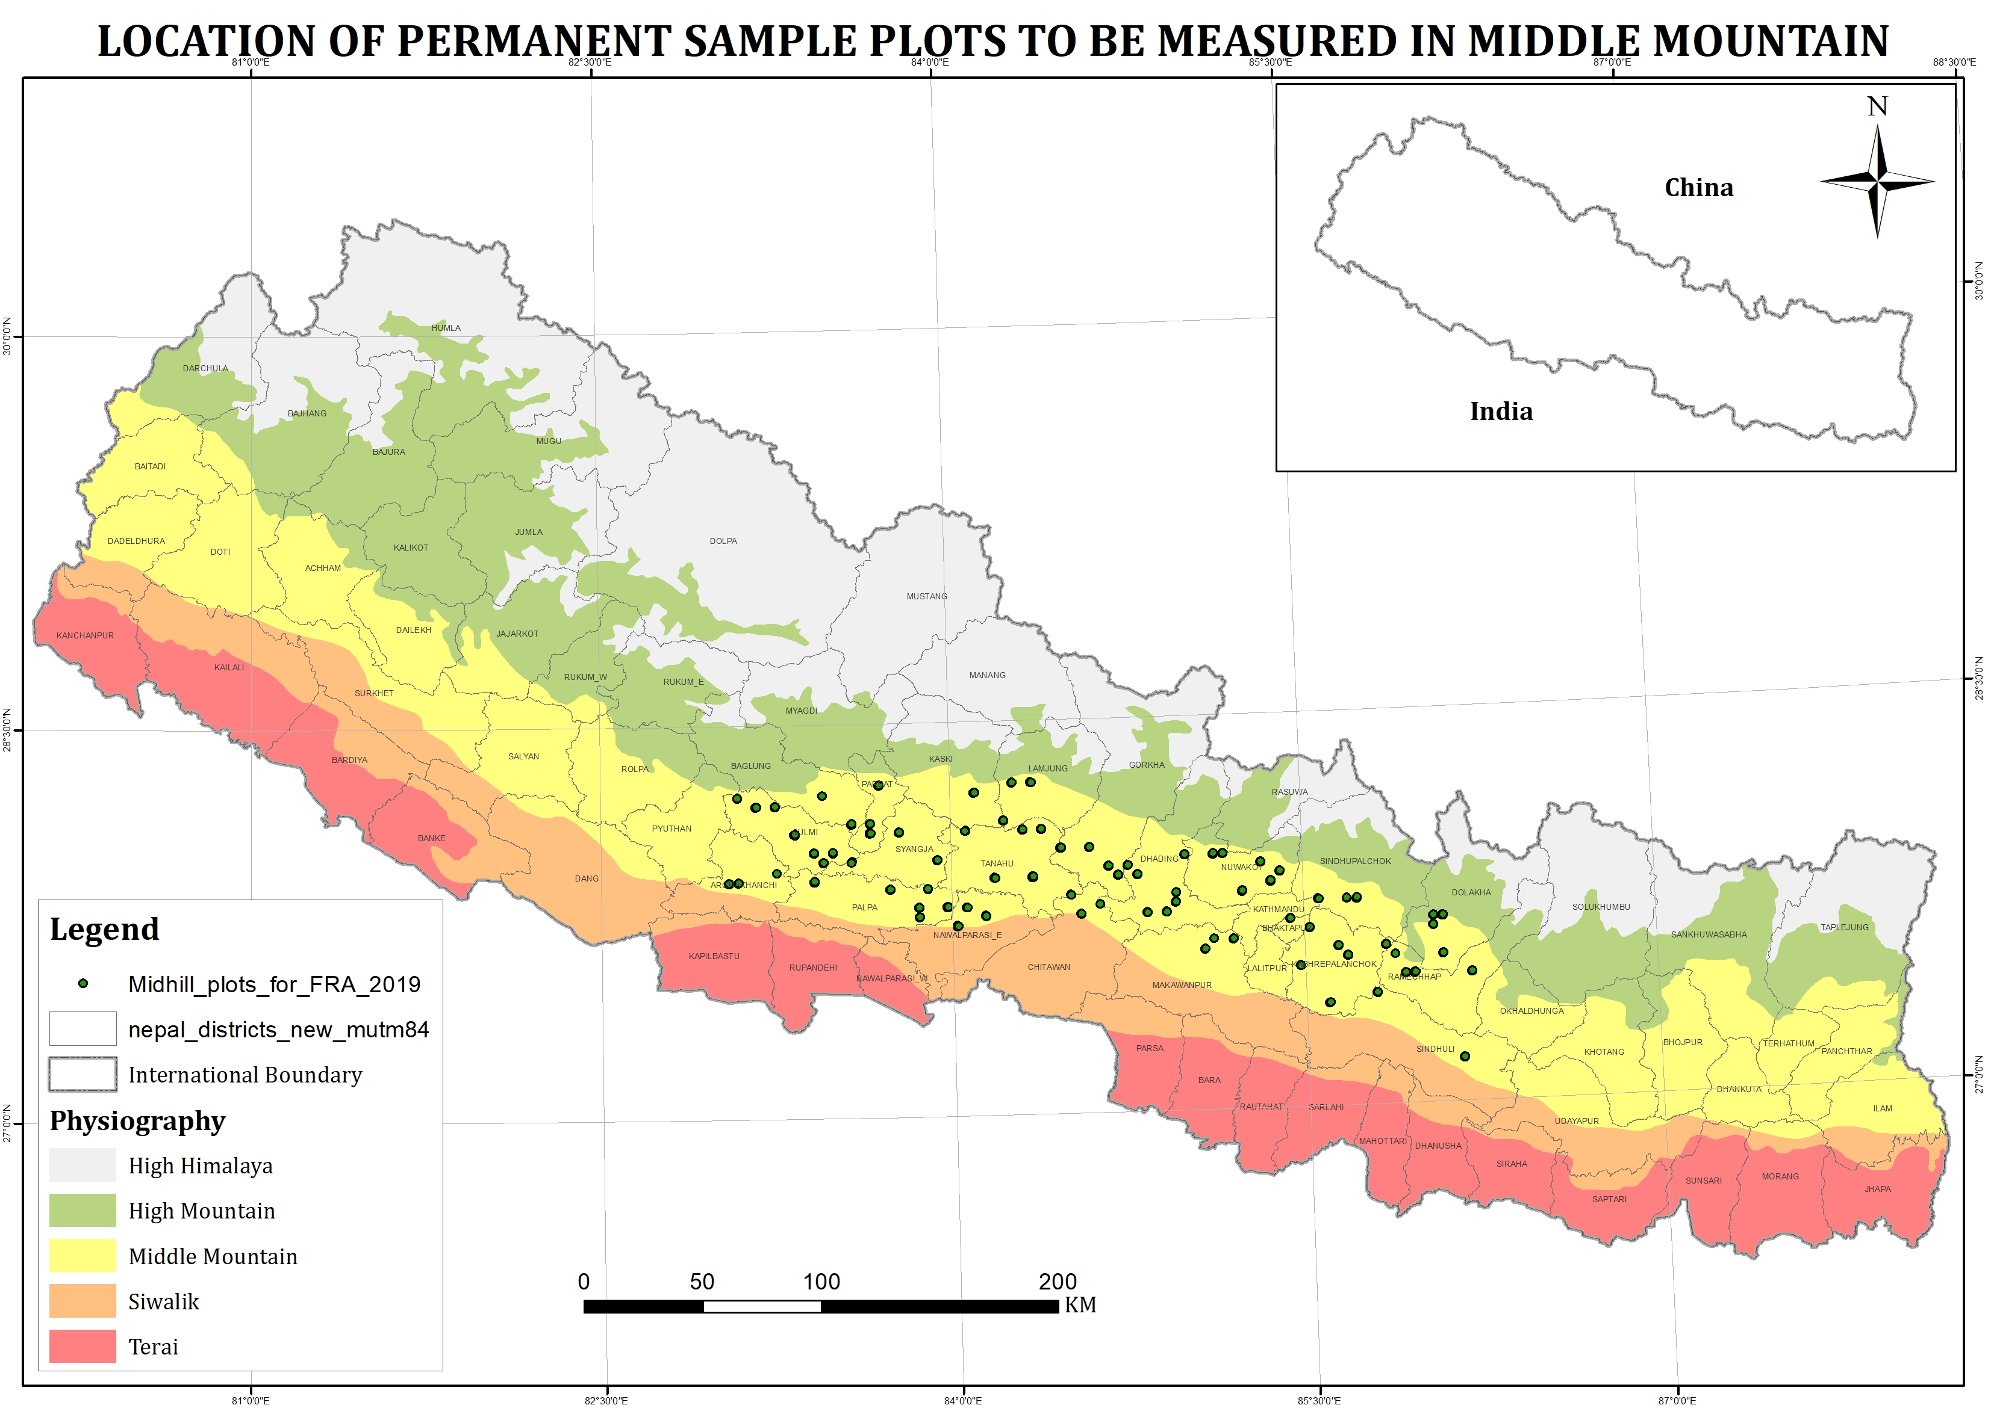

ANNEX 3b: LOCATION MAP OF PSPs in HIGH MOUNTAIN AND HIGH HIMAL (CLUSTER 2)

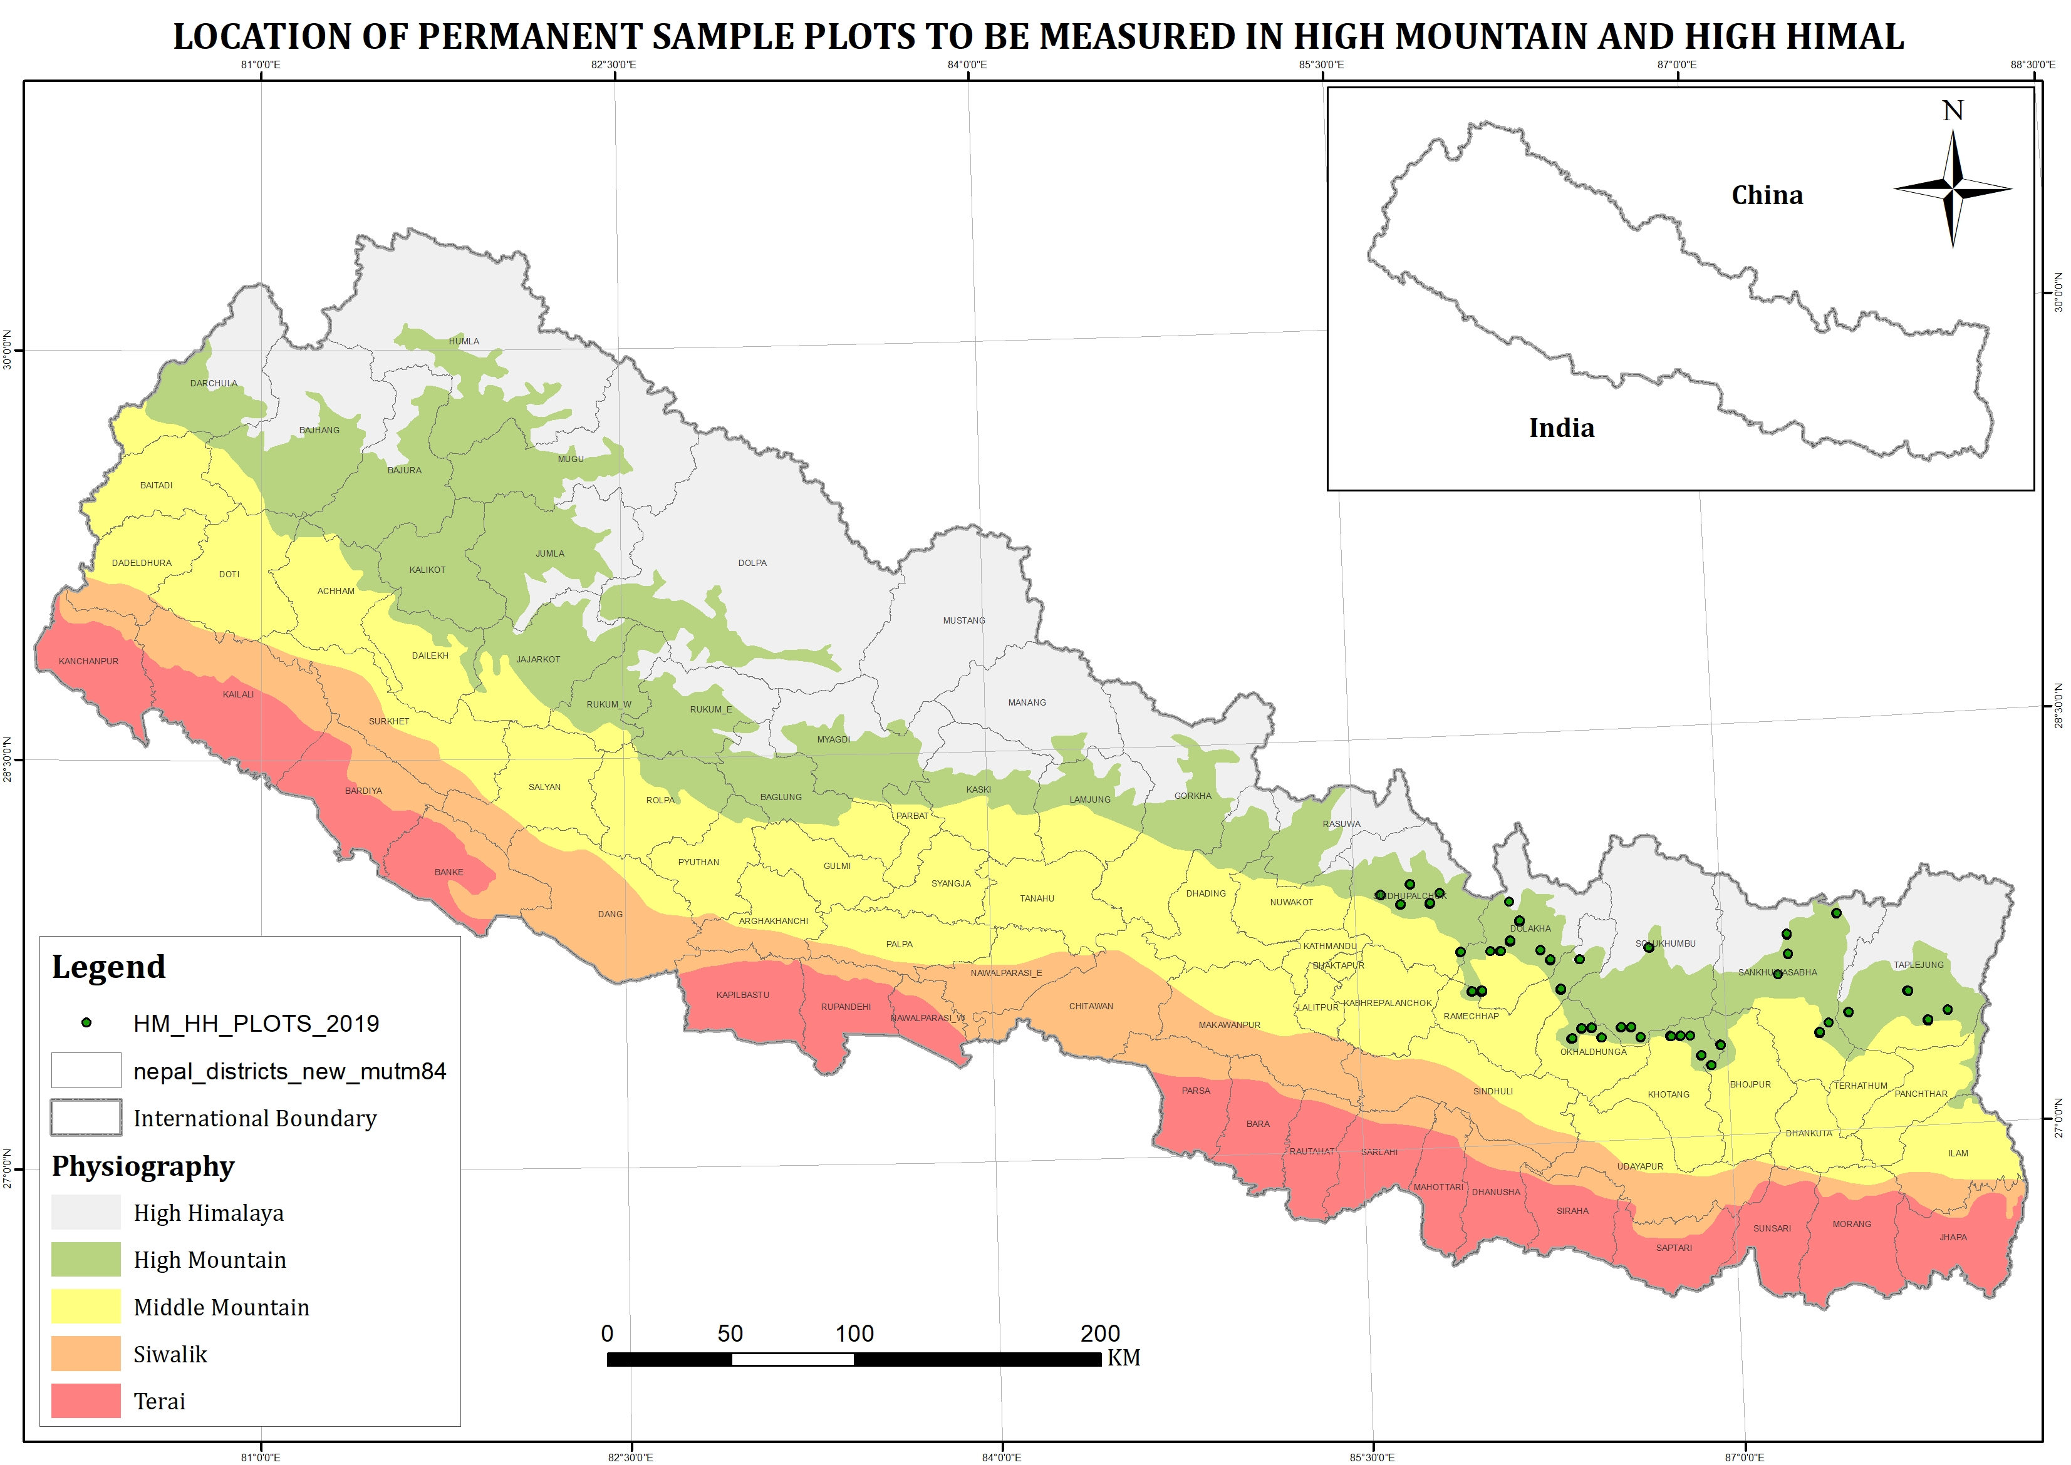

ANNEX 4: FIELD DATA COLLECTION TALLY SHEET
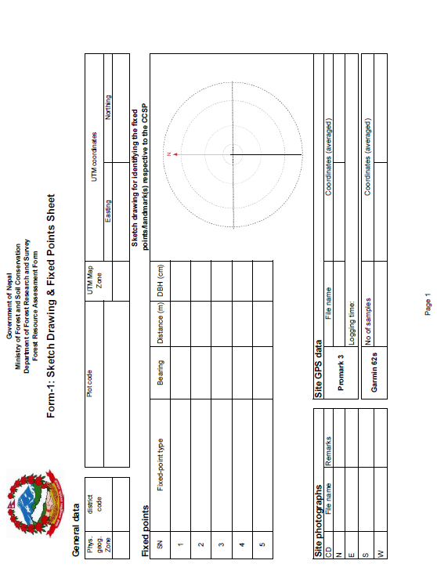

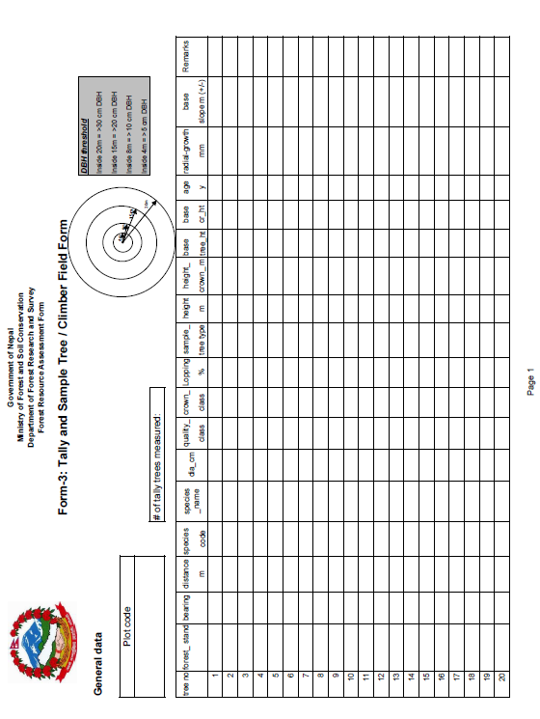

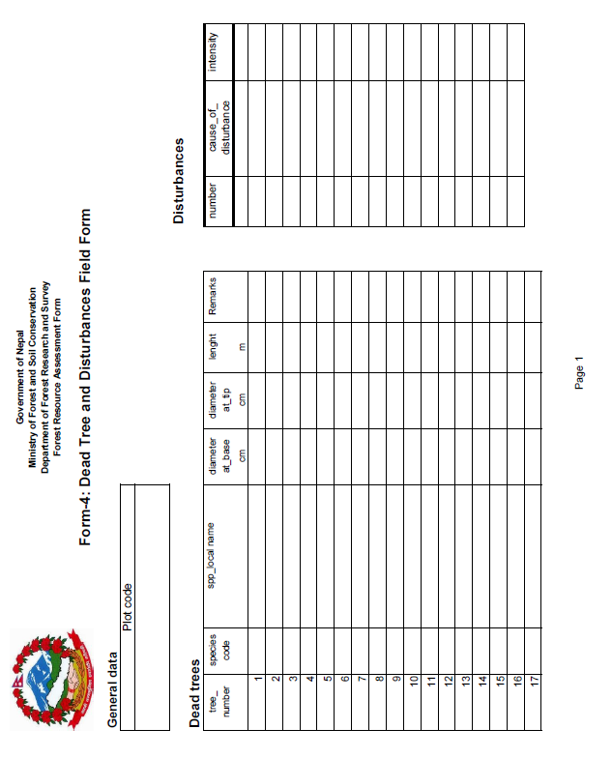

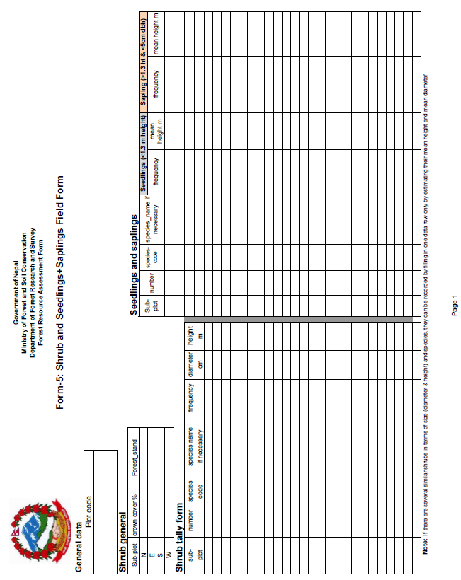

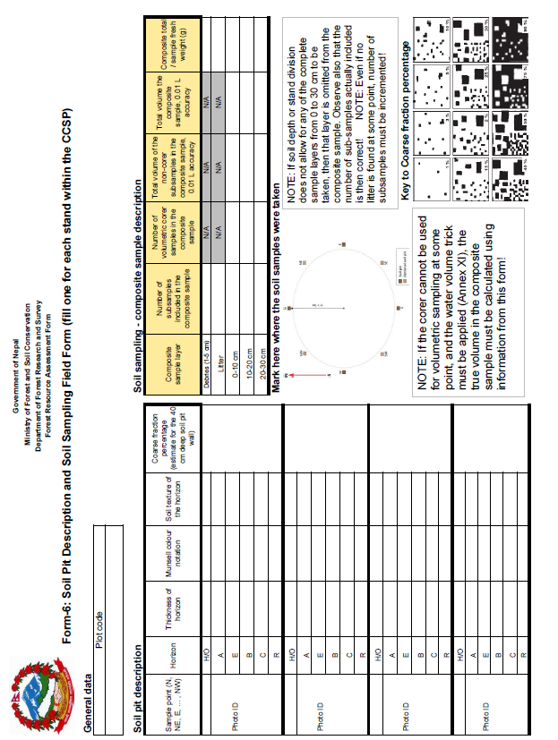

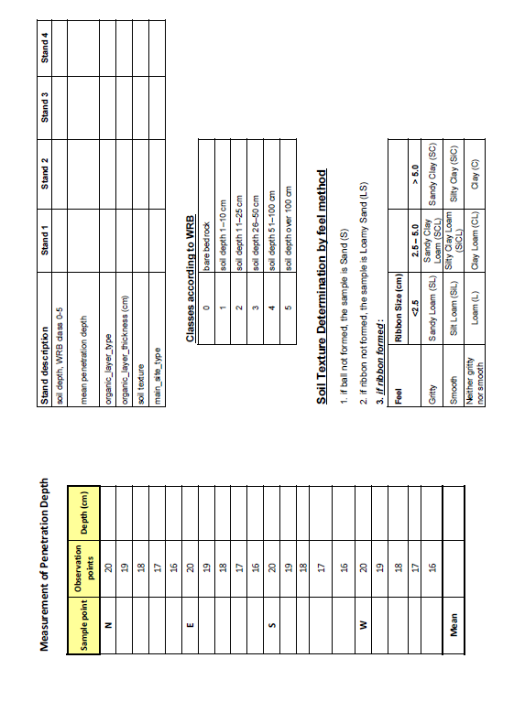

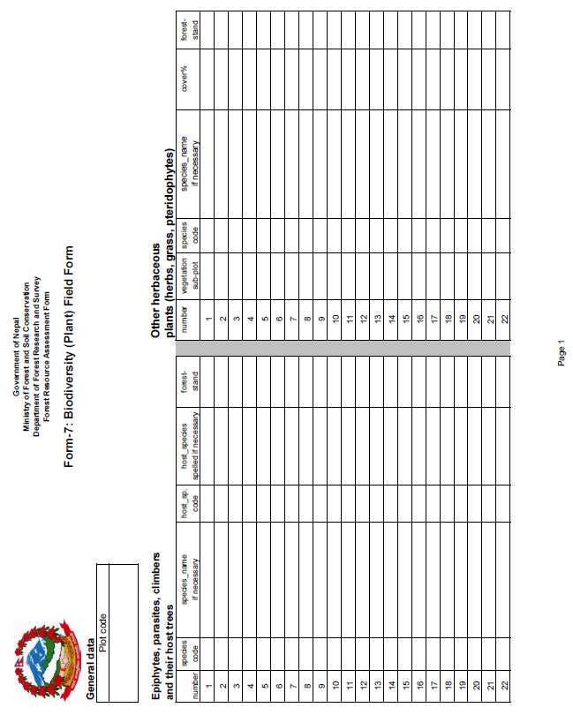

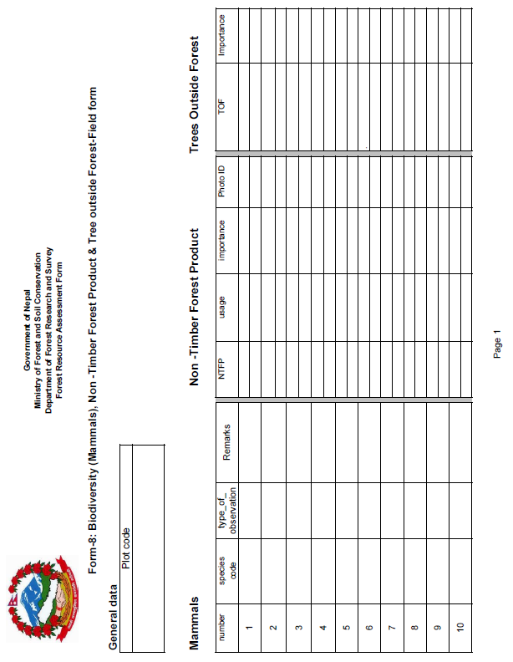

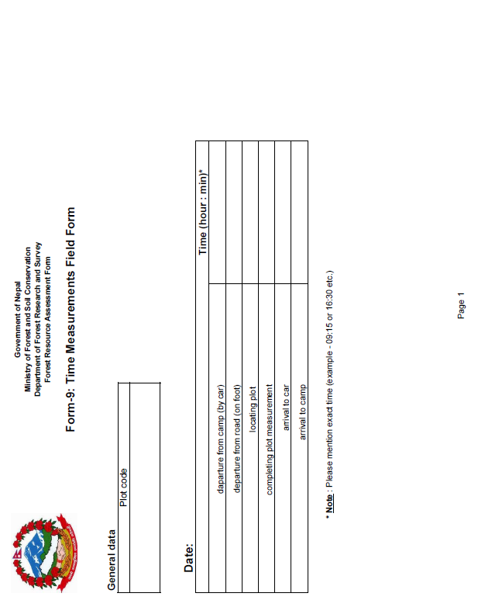

Section 8. Conditions of Contract and Contract Forms

Time-Based Form of Contract

STANDARD FORM OF CONTRACT

Consultant’s Services

Lump-Sum

Contents

Preface 35
I.Form of Contract 37
II.General Conditions of Contract 41
A. General Provisions 41
1.Definitions 41
2.Relationship Between the Parties 42
3.Law Governing Contract 43
4.Language 43
5.Headings 43
6.Communications 43
7.Location 43
8.Authority of Member in Charge 43
9.Authorized Representatives 43
10.Corrupt and Fraudulent Practices 43
B. Commencement, Completion, Modification and Termination of Contract 44
11.Effectiveness of Contract 44
12.Termination of Contract for Failure to Become Effective 44
13.Commencement of Services 44
14.Expiration of Contract 44
15.Entire Agreement 44
16.Modifications or Variations 44
17.Force Majeure 44
18.Suspension 46
19.Termination 46
C. Obligations of the Consultant 48
20.General 48
21.Conflict of Interests 49
22.Confidentiality 50
23.Liability of the Consultant 50
24.Insurance to be Taken out by the Consultant 50
25.Accounting, Inspection and Auditing 51
26.Reporting Obligations 51
27.Proprietary Rights of the Client in Reports and Records 51
28.Equipment, Vehicles and Materials 51
D. Consultant’s Experts and Sub-Consultants 52
29.Description of Key Experts 52
30.Replacement of Key Experts 52
31.Removal of Experts or Sub-consultants 52
E. Obligations of the Client 53
32.Assistance and Exemptions 53
33.Access to Project Site 53
34.Change in the Applicable Law Related to Taxes and Duties 54
35.Services, Facilities and Property of the Client 54
36.Counterpart Personnel 54
37.Payment Obligation 54
F. Payments to the Consultant 54
38.Contract Price 54
39.Taxes and Duties 55
40.Currency of Payment 55
41.Mode of Billing and Payment 55
42.Interest on Delayed Payments 56
G. Fairness and Good Faith 56
43.Good Faith 56
H. Settlement of Disputes 56
44. Amicable Settlement 56
45.Dispute Resolution 56
Attachment 1: Bank’s Policy – Corrupt and Fraudulent Practices 57
III.Special Conditions of Contract 59
IV.Appendices 65
Appendix A – Terms of Reference 65
Appendix B - Key Experts 65
Appendix C – Breakdown of Contract Price 65
Appendix D - Form of Advance Payments Guarantee 69

Preface

- The standard Contract form consists of four parts: the Form of Contract to be signed by the Client and the Consultant, the General Conditions of Contract (GCC), including Attachment 1 (Bank’s Policy – Corrupt and Fraudulent Practices); the Special Conditions of Contract (SCC); and the Appendices.

- The General Conditions of Contract, including Attachment 1, shall not be modified. The Special Conditions of Contract that contain clauses specific to each Contract intend to supplement, but not over-write or otherwise contradict, the General Conditions.

Contract for Consultant’s Services

Lump-Sum

Project Name: National Forestry Inventory Re-measurement of Plots
IDA Grant No TF OA 4169

Contract No: NP-REDD-94160-CS-QCBS

between

Government of Nepal
Ministry of Forests and Environment
REDD Implementation Centre, Babarmahal

and

[Name of the Consultant]

Dated:

Form of Contract
Lump-Sum

(Text in brackets [ ] is optional; all notes should be deleted in the final text)

This CONTRACT (hereinafter called the “Contract”) is made the [number] day of the month of [month], [year], between, on the one hand, [name of Client or Recipient] (hereinafter called the “Client”) and, on the other hand, [name of Consultant] (hereinafter called the “Consultant”).

[If the Consultant consist of more than one entity, the above should be partially amended to read as follows: “…(hereinafter called the “Client”) and, on the other hand, a Joint Venture (name of the JV) consisting of the following entities, each member of which will be jointly and severally liable to the Client for all the Consultant’s obligations under this Contract, namely, [name of member] and [name of member] (hereinafter called the “Consultant”).]

WHEREAS

(a) the Client has requested the Consultant to provide certain consulting services as defined in this Contract (hereinafter called the “Services”);

(b) the Consultant, having represented to the Client that it has the required professional skills, expertise and technical resources, has agreed to provide the Services on the terms and conditions set forth in this Contract;

(c) the Client has received [or has applied for] a loan [or credit or grant] from the [insert as relevant, International Bank for Reconstruction and Development (IBRD) or International Development Association (IDA)]:toward the cost of the Services and intends to apply a portion of the proceeds of this [loan/credit/grant] to eligible payments under this Contract, it being understood that (i) payments by the Bank will be made only at the request of the Client and upon approval by the Bank; (ii) such payments will be subject, in all respects, to the terms and conditions of the [loan/financing/grant]agreement, including prohibitions of withdrawal from the [loan/credit/grant] account for the purpose of any payment to persons or entities, or for any import of goods, if such payment or import, to the knowledge of the Bank, is prohibited by the decision of the United Nations Security council taken under Chapter VII of the Charter of the United Nations; and (iii) no party other than the Client shall derive any rights from the [loan/financing/grant] agreement or have any claim to the [loan/credit/grant] proceeds;

NOW THEREFORE the parties hereto hereby agree as follows:

1. The following documents attached hereto shall be deemed to form an integral part of this Contract:

(a) The General Conditions of Contract(including Attachment 1 “Bank Policy – Corrupt and Fraudulent Practices);
(b) The Special Conditions of Contract;
(c) Appendices:

Appendix A: Terms of Reference
Appendix B: Key Experts
Appendix C: Breakdown of Contract Price
Appendix D: Form of Advance Payments Guarantee

In the event of any inconsistency between the documents, the following order of precedence shall prevail: the Special Conditions of Contract; the General Conditions of Contract, including Attachment 1; Appendix A; Appendix B; Appendix C; Appendix D. Any reference to this Contract shall include, where the context permits, a reference to its Appendices.

2. The mutual rights and obligations of the Client and the Consultant shall be as set forth in the Contract, in particular:

(a) the Consultant shall carry out the Services in accordance with the provisions of the Contract; and
(b) the Client shall make payments to the Consultant in accordance with the provisions of the Contract.

IN WITNESS WHERE OF, the Parties here to have caused this Contract to be signed in their respective names as of the day and year first above written.

For and on behalf of REDD Implementation Centre

[Radha Wagle, Chief, Joint Secretary (Tech.)

For and on behalf of [Name of Consultant or Name of a Joint Venture]

[Authorized Representative of the Consultant – name and signature]

[For a joint venture, either all members shall sign or only the lead member, in which case the power of attorney to sign on behalf of all members shall be attached.

For and on behalf of each of the members of the Consultant [insert the Name of the Joint Venture]

[Name of the lead member]

[Authorized Representative on behalf of a Joint Venture]

[add signature blocks for each member if all are signing]

General Conditions of Contract

A. General Provisions
- Definitions | - Unless the context otherwise requires, the following terms whenever used in this Contract have the following meanings:  - “Applicable Guidelines” means Guidelines for Selection and Employment of Consultants under IBRD Loans and IDA Credits & Grants by World Bank Borrowers, dated January 2011.  - “Applicable Law” means the laws and any other instruments having the force of law in the Client’s country, or in such other country as may be specified in the Special Conditions of Contract (SCC), as they may be issued and in force from time to time.  - “Bank” means the International Bank for Reconstruction and Development (IBRD) or the International Development Association (IDA).  - “Borrower” means the Government, Government agency or other entity thatsigns the financing agreementwith the Bank.  - “Client” means the implementing agency that signs the Contract for the Services with the Selected Consultant.  - “Consultant” means a legally-established professional consulting firm or entity selected by the Client to provide the Services under the signed Contract.  - “Contract” means the legally binding written agreement signed between the Client and the Consultant and which includes all the attached documents listed in its paragraph 1 of the Form of Contract (the General Conditions (GCC), the Special Conditions (SCC), and the Appendices).  - “Day” means a working day unless indicated otherwise.  - “Effective Date” means the date on which this Contract comes into force and effect pursuant to Clause GCC 11.  - “Experts” means, collectively, Key Experts, Non-Key Experts, or any other personnel of the Consultant, Sub-consultant or JV member(s) assigned by the Consultant to perform the Services or any part thereof under the Contract.  - “Foreign Currency” means any currency other than the currency of the Client’s country.  - “GCC” means these General Conditions of Contract.  - “Government” means the government of the Client’s country.  - “Joint Venture (JV)” means an associationwith or without a legal personality distinct from that of its members, of more than one entity where one member has the authority to conduct all businesses for and on behalf of any and all the members of the JV, and where the members of the JV are jointly and severally liable to the Client for the performance of the Contract.  - “Key Expert(s)” means an individual professional whose skills, qualifications, knowledge and experience are critical to the performance of the Services under the Contract and whose Curricula Vitae (CV) was taken into account in the technical evaluation of the Consultant’s proposal.  - “Local Currency” means the currency of the Client’s country.  - “Non-Key Expert(s)” means an individual professional provided by the Consultant or its Sub-consultant to perform the Services or any part thereof under the Contract.  - “Party” means the Client or the Consultant, as the case may be, and “Parties” means both of them.  - “SCC” means the Special Conditions of Contract by which the GCC may be amended or supplemented but not over-written.  - “Services” means the work to be performed by the Consultant pursuant to this Contract, as described in Appendix A hereto.  - “Sub-consultants” means an entity to whom/which the Consultant subcontracts any part of the Services while remaining solely liable for the execution of the Contract.  - “Third Party” means any person or entity other than the Government, the Client, the Consultant or a Sub-consultant.
Relationship between the Parties | - Nothing contained herein shall be construed as establishing a relationship of master and servant or of principal and agent as between the Client and the Consultant. The Consultant, subject to this Contract, has complete charge of the Experts and Sub-consultants, if any, performing the Services and shall be fully responsible for the Services performed by them or on their behalf hereunder.
Law Governing Contract | - This Contract, its meaning and interpretation, and the relation between the Parties shall be governed by the Applicable Law.
Language | - This Contract has been executed in the language specified in the SCC, which shall be the binding and controlling language for all matters relating to the meaning or interpretation of this Contract.
Headings | - The headings shall not limit, alter or affect the meaning of this Contract.
Communications | - Any communication required or permitted to be given or made pursuant to this Contract shall be in writing in the language specified in Clause GCC 4. Any such notice, request or consent shall be deemed to have been given or made when delivered in person to an authorized representative of the Party to whom the communication is addressed, or when sent to such Party at the address specified in the SCC.  - A Party may change its address for notice hereunder by giving the other Party any communication of such change to the address specified in the SCC.
Location | - The Services shall be performed at such locations as are specified in Appendix A hereto and, where the location of a particular task is not so specified, at such locations, whether in the Government’s country or elsewhere, as the Client may approve.
Authority of Member in Charge | - In case the Consultant is a Joint Venture, the members hereby authorize the member specified in the SCC to act on their behalf in exercising all the Consultant’s rights and obligations towards the Client under this Contract, including without limitation the receiving of instructions and payments from the Client.
Authorized Representatives | - Any action required or permitted to be taken, and any document required or permitted to be executed under this Contract by the Client or the Consultant may be taken or executed by the officials specified in the SCC.
Corrupt and Fraudulent Practices | - The Bank requires compliance with its policy in regard to corrupt and fraudulentpractices as set forth in Attachment 1 to the GCC.
a. Commissions and Fees | - The Client requires the Consultant to disclose any commissions, gratuities or fees that may have been paid or are to be paid to agents or any other party with respect to the selection process or execution of the Contract. The information disclosed must include at least the name and address of the agent or other party, the amount and currency, and the purpose of the commission, gratuity or fee. Failure to disclose such commissions, gratuities or fees may result in termination of the Contract and/or sanctions by the Bank.

B. Commencement, Completion, Modification and Termination of Contract
Effectiveness of Contract | - This Contract shall come into force and effect on the date (the “Effective Date”) of the Client’s notice to the Consultant instructing the Consultant to begin carrying out the Services. This notice shall confirm that the effectiveness conditions, if any, listed in the SCC have been met.
Termination of Contract for Failure to Become Effective | - If this Contract has not become effective within such time period after the date of Contract signature as specified in the SCC, either Party may, by not less than twenty two (22) days written notice to the other Party, declare this Contract to be null and void, and in the event of such a declaration by either Party, neither Party shall have any claim against the other Party with respect hereto.
Commencement of Services | - The Consultant shall confirm availability of Key Experts and begin carrying out the Services not later than the number of days after the Effective Date specified in the SCC.
Expiration of Contract | - Unless terminated earlier pursuant to Clause GCC 19 hereof, this Contract shall expire at the end of such time period after the Effective Date as specified in the SCC.
Entire Agreement | - This Contract contains all covenants, stipulations and provisions agreed by the Parties. No agent or representative of either Party has authority to make, and the Parties shall not be bound by or be liable for, any statement, representation, promise or agreement not set forth herein.
Modifications or Variations | - Any modification or variation of the terms and conditions of this Contract, including any modification or variation of the scope of the Services, may only be made by written agreement between the Parties. However, each Party shall give due consideration to any proposals for modification or variation made by the other Party.  - In cases of substantial modifications or variations, the prior written consent of the Bank is required.

Force Majeure
a. Definition | - For the purposes of this Contract, “Force Majeure” means an event which is beyond the reasonable control of a Party, is not foreseeable, is unavoidable, and makes a Party’s performance of its obligations hereunder impossible or so impractical as reasonably to be considered impossible under the circumstances, and subject to those requirements, includes, but is not limited to, war, riots, civil disorder, earthquake, fire, explosion, storm, flood or other adverse weather conditions, strikes, lockouts or other industrial action confiscation or any other action by Government agencies.  - Force Majeure shall not include (i) any event which is caused by the negligence or intentional action of a Party or such Party’s Experts, Sub-consultants or agents or employees, nor (ii) any event which a diligent Party could reasonably have been expected to both take into account at the time of the conclusion of this Contract, and avoid or overcome in the carrying out of its obligations hereunder.  - Force Majeure shall not include insufficiency of funds or failure to make any payment required hereunder.
b. No Breach of Contract | - The failure of a Party to fulfill any of its obligations hereunder shall not be considered to be a breach of, or default under, this Contract insofar as such inability arises from an event of Force Majeure, provided that the Party affected by such an event has taken all reasonable precautions, due care and reasonable alternative measures, all with the objective of carrying out the terms and conditions of this Contract.
c. Measures to be Taken | - A Party affected by an event of Force Majeure shall continue to perform its obligations under the Contract as far as is reasonably practical, and shall take all reasonable measures to minimize the consequences of any event of Force Majeure.  - A Party affected by an event of Force Majeure shall notify the other Party of such event as soon as possible, and in any case not later than fourteen (14) calendar days following the occurrence of such event, providing evidence of the nature and cause of such event, and shall similarly give written notice of the restoration of normal conditions as soon as possible.  - Any period within which a Party shall, pursuant to this Contract, complete any action or task, shall be extended for a period equal to the time during which such Party was unable to perform such action as a result of Force Majeure.  - During the period of their inability to perform the Services as a result of an event of Force Majeure, the Consultant, upon instructions by the Client, shall either:  (a) demobilize, in which case the Consultant shall be reimbursed for additional costs they reasonably and necessarily incurred, and, if required by the Client, in reactivating the Services; or  (b) continue with the Services to the extent reasonably possible, in which case the Consultant shall continue to be paid under the terms of this Contract and be reimbursed for additional costs reasonably and necessarily incurred.  - In the case of disagreement between the Parties as to the existence or extent of Force Majeure, the matter shall be settled according to Clauses GCC 44& 45.
Suspension | The Client may, by written notice of suspension to the Consultant, suspend all payments to the Consultant hereunder if the Consultant fails to perform any of its obligations under this Contract, including the carrying out of the Services, provided that such notice of suspension (i) shall specify the nature of the failure, and (ii) shall request the Consultant to remedy such failure within a period not exceeding thirty (30) calendar days after receipt by the Consultant of such notice of suspension.
Termination | 19.1. This Contract may be terminated by either Party as per provisions set up below:
a. By the Client | 19.1.1. The Client may terminate this Contract in case of the occurrence of any of the events specified in paragraphs (a) through (f) of this Clause. In such an occurrence the Client shall give at least thirty (30) calendar days’ written notice of termination to the Consultant in case of the events referred to in (a) through (d); at least sixty (60) calendar days’ written notice in case of the event referred to in (e); and at least five (5) calendar days’ written notice in case of the event referred to in (f):  (a) If the Consultant fails to remedy a failure in the performance of its obligations hereunder, as specified in a notice of suspension pursuant to Clause GCC 18;  (b) If the Consultant becomes (or, if the Consultant consists of more than one entity, if any of its members becomes) insolvent or bankrupt or enter into any agreements with their creditors for relief of debt or take advantage of any law for the benefit of debtors or go into liquidation or receivership whether compulsory or voluntary;  (c) If the Consultant fails to comply with any final decision reached as a result of arbitration proceedings pursuant to Clause GCC 45.1;  (d) If, as the result of Force Majeure, the Consultant is unable to perform a material portion of the Services for a period of not less than sixty (60) calendar days;  (e) If the Client, in its sole discretion and for any reason whatsoever, decides to terminate this Contract;  (f) If the Consultant fails to confirm availability of Key Experts as required in Clause GCC 13.  19.1.2. Furthermore, if the Client determines that the Consultant has engaged in corrupt, fraudulent, collusive, coercive or obstructive practices, in competing for or in executing the Contract, then the Client may, after giving fourteen (14) calendar days written notice to the Consultant, terminate the Consultant's employment under the Contract.
b. By the Consultant | 19.1.3. The Consultant may terminate this Contract, by not less than thirty (30) calendar days’ written notice to the Client, in case of the occurrence of any of the events specified in paragraphs (a) through (d) of this Clause.  (a) If the Client fails to pay any money due to the Consultant pursuant to this Contract and not subject to dispute pursuant to Clause GCC 45.1 within forty-five (45) calendar days after receiving written notice from the Consultant that such payment is overdue.  (b) If, as the result of Force Majeure, the Consultant is unable to perform a material portion of the Services for a period of not less than sixty (60) calendar days.  (c) If the Client fails to comply with any final decision reached as a result of arbitration pursuant to Clause GCC 45.1.  (d) If the Client is in material breach of its obligations pursuant to this Contract and has not remedied the same within forty-five (45) days (or such longer period as the Consultant may have subsequently approved in writing) following the receipt by the Client of the Consultant’s notice specifying such breach.
c. Cessation of Rights and Obligations | 19.1.4. Upon termination of this Contract pursuant to Clauses GCC 12 or GCC 19 hereof, or upon expiration of this Contract pursuant to Clause GCC 14, all rights and obligations of the Parties hereunder shall cease, except (i) such rights and obligations as may have accrued on the date of termination or expiration, (ii) the obligation of confidentiality set forth in Clause GCC 22, (iii) the Consultant’s obligation to permit inspection, copying and auditing of their accounts and records set forth in Clause GCC 25, and (iv) any right which a Party may have under the Applicable Law.
d. Cessation of Services | 19.1.5. Upon termination of this Contract by notice of either Party to the other pursuant to Clauses GCC 19a or GCC 19b, the Consultant shall, immediately upon dispatch or receipt of such notice, take all necessary steps to bring the Services to a close in a prompt and orderly manner and shall make every reasonable effort to keep expenditures for this purpose to a minimum. With respect to documents prepared by the Consultant and equipment and materials furnished by the Client, the Consultant shall proceed as provided, respectively, by Clauses GCC 27 or GCC 28.
e. Payment upon Termination | 19.1.6. Upon termination of this Contract, the Client shall make the following payments to the Consultant:  (a) payment for Services satisfactorily performed prior to the effective date of termination; and  (b) in the case of termination pursuant to paragraphs (d) and (e) of Clause GCC19.1.1, reimbursement of any reasonable cost incidental to the prompt and orderly termination of this Contract, including the cost of the return travel of the Experts.

C. Obligations of the Consultant

General
a. Standard of Performance | 20.1 The Consultant shall perform the Services and carry out the Services with all due diligence, efficiency and economy, in accordance with generally accepted professional standards and practices, and shall observe sound management practices, and employ appropriate technology and safe and effective equipment, machinery, materials and methods. The Consultant shall always act, in respect of any matter relating to this Contract or to the Services, as a faithful adviser to the Client, and shall at all times support and safeguard the Client’s legitimate interests in any dealings with the third parties.  20.2. The Consultant shall employ and provide such qualified and experienced Experts and Sub-consultants as are required to carry out the Services.  20.3. The Consultant may subcontract part of the Services to an extent and with such Key Experts and Sub-consultants as may be approved in advance by the Client. Notwithstanding such approval, the Consultant shall retain full responsibility for the Services.
b. Law Applicable to Services | 20.4. The Consultant shall perform the Services in accordance with the Contract and the Applicable Law and shall take all practicable steps to ensure that any of its Experts and Sub-consultants, comply with the Applicable Law.  20.5. Throughout the execution of the Contract, the Consultant shall comply with the import of goods and services prohibitions in the Client’s country when  (a) as a matter of law or official regulations, the Borrower’s country prohibits commercial relations with that country; or  (b) by an act of compliance with a decision of the United Nations Security Council taken under Chapter VII of the Charter of the United Nations, the Borrower’s Country prohibits any import of goods from that country or any payments to any country, person, or entity in that country.  20.6. The Client shall notify the Consultant in writing of relevant local customs, and the Consultant shall, after such notification, respect such customs.
Conflict of Interests | 21.1. The Consultant shall hold the Client’s interests paramount, without any consideration for future work, and strictly avoid conflict with other assignments or their own corporate interests.
a. Consultant Not to Benefit from Commissions,Discounts, etc. | 21.1.1 The payment of the Consultant pursuant to GCC F (Clauses GCC 38 through 42) shall constitute the Consultant’s only payment in connection with this Contract and, subject to Clause GCC 21.1.3, the Consultant shall not accept for its own benefit any trade commission, discount or similar payment in connection with activities pursuant to this Contract or in the discharge of its obligations hereunder, and the Consultant shall use its best efforts to ensure that any Sub-consultants, as well as the Experts and agents of either of them, similarly shall not receive any such additional payment.  21.1.2 Furthermore, if the Consultant, as part of the Services, has the responsibility of advising the Client on the procurement of goods, works or services, the Consultant shall comply with the Bank’s Applicable Guidelines, and shall at all times exercise such responsibility in the best interest of the Client. Any discounts or commissions obtained by the Consultant in the exercise of such procurement responsibility shall be for the account of the Client.
b. Consultant and Affiliates Not to Engage in Certain Activities | 21.1.3 The Consultant agrees that, during the term of this Contract and after its termination, the Consultant and any entity affiliated with the Consultant, as well as any Sub-consultants and any entity affiliated with such Sub-consultants, shall be disqualified from providing goods, works or non-consultingservices resulting from or directly related to the Consultant’s Services for the preparation or implementation of the project, unless otherwise indicated in the SCC.
c. Prohibition of Conflicting Activities | 21.1.4 The Consultant shall not engage, and shall cause its Experts as well as its Sub-consultants not to engage, either directly or indirectly, in any business or professional activities that would conflict with the activities assigned to them under this Contract.
d. Strict Duty to Disclose Conflicting Activities | 21.1.5 The Consultant has an obligation and shall ensure that its Experts and Sub-consultants shall have an obligation to disclose any situation of actual or potential conflict that impacts their capacity to serve the best interest of their Client, or that may reasonably be perceived as having this effect. Failure to disclose said situations may lead to the disqualification of the Consultant or the termination of its Contract.
Confidentiality | 22.1 Except with the prior written consent of the Client, the Consultant and the Experts shall not at any time communicate to any person or entity any confidential information acquired in the course of the Services, nor shall the Consultant and the Experts make public the recommendations formulated in the course of, or as a result of, the Services.
Liability of the Consultant | 23.1 Subject to additional provisions, if any, set forth in the SCC, the Consultant’s liability under this Contract shall be provided by the Applicable Law.
Insurance to be Taken out by the Consultant | 24.1 The Consultant (i) shall take out and maintain, and shall cause any Sub-consultants to take out and maintain, at its (or the Sub-consultants’, as the case may be) own cost but on terms and conditions approved by the Client, insurance against the risks, and for the coverage specified in the SCC, and (ii) at the Client’s request, shall provide evidence to the Client showing that such insurance has been taken out and maintained and that the current premiums therefore have been paid. The Consultant shall ensure that such insurance is in place prior to commencing the Services as stated in Clause GCC 13.
Accounting, Inspection and Auditing | 25.1 The Consultant shall keep, and shall make all reasonable efforts to cause its Sub-consultants to keep, accurate and systematic accounts and records in respect of the Services and in such form and detail as will clearly identify relevant time changes and costs.  25.2 The Consultant shall permit and shall cause its Sub-consultants to permit, the Bank and/or persons appointed by the Bank to inspect the Site and/or all accounts and records relating to the performance of the Contract and the submission of the Proposal to provide the Services, and to have such accounts and records audited by auditors appointed by the Bank if requested by the Bank. The Consultant’s attention is drawn to Clause GCC 10 which provides, inter alia, that acts intended to materially impede the exercise of the Bank’s inspection and audit rights provided for under this Clause GCC25.2 constitute a prohibited practice subject to contract termination (as well as to a determination of ineligibility under the Bank’s prevailing sanctions procedures.)
Reporting Obligations | 26.1 The Consultant shall submit to the Client the reports and documents specified in Appendix A, in the form, in the numbers and within the time periods set forth in the said Appendix.
Proprietary Rights of the Client in Reports and Records | 27.1 Unless otherwise indicated in the SCC, all reports and relevant data and information such as maps, diagrams, plans, databases, other documents and software, supporting records or material compiled or prepared by the Consultant for the Client in the course of the Services shall be confidential and become and remain the absolute property of the Client. The Consultant shall, not later than upon termination or expiration of this Contract, deliver all such documents to the Client, together with a detailed inventory thereof. The Consultant may retain a copy of such documents, data and/or software but shall not use the same for purposes unrelated to this Contract without prior written approval of the Client.  27.2 If license agreements are necessary or appropriate between the Consultant and third parties for purposes of development of the plans, drawings, specifications, designs, databases, other documents and software, the Consultant shall obtain the Client’s prior written approval to such agreements, and the Client shall be entitled at its discretion to require recovering the expenses related to the development of the program(s) concerned. Other restrictions about the future use of these documents and software, if any, shall be specified in the SCC.
Equipment, Vehicles and Materials | 28.1 Equipment, vehicles and materials made available to the Consultant by the Client, or purchased by the Consultant wholly or partly with funds provided by the Client, shall be the property of the Client and shall be marked accordingly. Upon termination or expiration of this Contract, the Consultant shall make available to the Client an inventory of such equipment, vehicles and materials and shall dispose of such equipment, vehicles and materials in accordance with the Client’s instructions. While in possession of such equipment, vehicles and materials, the Consultant, unless otherwise instructed by the Client in writing, shall insure them at the expense of the Client in an amount equal to their full replacement value.  28.2 Any equipment or materials brought by the Consultant or its Experts into the Client’s country for the use either for the project or personal use shall remain the property of the Consultant or the Experts concerned, as applicable.

D. Consultant’s Experts andSub-Consultants
Description of Key Experts | 29.1 The title, agreed job description, minimum qualification and estimated period of engagement to carry out the Services of each of the Consultant’s Key Experts are described in Appendix B.
Replacement of Key Experts | 30.1 Except as the Client may otherwise agree in writing, no changes shall be made in the Key Experts.  30.2 Notwithstanding the above, the substitution of Key Experts during Contract execution may be considered only based on the Consultant’s written request and due to circumstances outside the reasonable control of the Consultant, including but not limited to death or medical incapacity. In such case, the Consultant shall forthwith provide as a replacement, a person of equivalent or better qualifications and experience, and at the same rate of remuneration.
Removal of Experts or Sub-consultants | 31.1 If the Client finds that any of the Experts or Sub-consultant has committed serious misconduct or has been charged with having committed a criminal action, or shall the Client determine that Consultant’s Expert of Sub-consultant have engaged in corrupt, fraudulent, collusive, coercive or obstructivepractice while performing the Services, the Consultant shall, at the Client’s written request, provide a replacement.  31.2 In the event that any of Key Experts, Non-Key Experts or Sub-consultants is found by the Client to be incompetent or incapable in discharging assigned duties, the Client, specifying the grounds therefore, may request the Consultant to provide a replacement.  31.3 Any replacement of the removed Experts or Sub-consultants shall possess better qualifications and experience and shall be acceptable to the Client.  31.4 The Consultant shall bear all costs arising out of or incidental to any removal and/or replacement of such Experts.

E. Obligations of the Client
Assistance and Exemptions | 32.1 Unless otherwise specified in the SCC, the Client shall use its best efforts to:  (a) Assist the Consultant with obtaining work permits and such other documents as shall be necessary to enable the Consultant to perform the Services.  (b) Assist the Consultant with promptly obtaining, for the Experts and, if appropriate, their eligible dependents, all necessary entry and exit visas, residence permits, exchange permits and any other documents required for their stay in the Client’s country while carrying out the Services under the Contract.  (c) Facilitate prompt clearance through customs of any property required for the Services and of the personal effects of the Experts and their eligible dependents.  (c) Issue to officials, agents and representatives of the Government all such instructions and information as may be necessary or appropriate for the prompt and effective implementation of the Services.  (d) Assist the Consultant and the Experts and any Sub-consultants employed by the Consultant for the Services with obtaining exemption from any requirement to register or obtain any permit to practice their profession or to establish themselves either individually or as a corporate entity in the Client’s country according to the applicable law in the Client’s country.  (e) Assist the Consultant, any Sub-consultants and the Experts of either of them with obtaining the privilege, pursuant to the applicable law in the Client’s country, of bringing into the Client’s country reasonable amounts of foreign currency for the purposes of the Services or for the personal use of the Experts and of withdrawing any such amounts as may be earned therein by the Experts in the execution of the Services.  (f) Provide to the Consultant any such other assistance as may be specified in the SCC.
Access to Project Site | 33.1 The Client warrants that the Consultant shall have, free of charge, unimpeded access to the project site in respect of which access is required for the performance of the Services. The Client will be responsible for any damage to the project site or any property thereon resulting from such access and will indemnify the Consultant and each of the experts in respect of liability for any such damage, unless such damage is caused by the willful default or negligence of the Consultant or any Sub-consultants or the Experts of either of them.
Change in the Applicable Law Related to Taxes and Duties | 34.1 If, after the date of this Contract, there is any change in the applicable law in the Client’s country with respect to taxes and duties which increases or decreases the cost incurred by the Consultant in performing the Services, then the remuneration and reimbursable expenses otherwise payable to the Consultant under this Contract shall be increased or decreased accordingly by agreement between the Parties hereto, and corresponding adjustments shall be made to the Contract price amount specified in Clause GCC 38.1
Services, Facilities and Property of the Client | 35.1 The Client shall make available to the Consultant and the Experts, for the purposes of the Services and free of any charge, the services, facilities and property described in the Terms of Reference (Appendix A) at the times and in the manner specified in said Appendix A.
Counterpart Personnel | 36.1 The Client shall make available to the Consultant free of charge such professional and support counterpart personnel, to be nominated by the Client with the Consultant’s advice, if specified in Appendix A.  36.2 Professional and support counterpart personnel, excluding Client’s liaison personnel, shall work under the exclusive direction of the Consultant. If any member of the counterpart personnel fails to perform adequately any work assigned to such member by the Consultant that is consistent with the position occupied by such member, the Consultant may request the replacement of such member, and the Client shall not unreasonably refuse to act upon such request.
Payment Obligation | 37.1 In consideration of the Services performed by the Consultant under this Contract, the Client shall make such payments to the Consultant for the deliverables specified in Appendix A and in such manner as is provided by GCC F below.

F. Payments to the Consultant
Contract Price | 38.1 The Contract price is fixed and is set forth in the SCC. The Contract price breakdown is provided in Appendix C.  38.2 Any change to the Contract price specified in Clause 38.1 can be made only if the Parties have agreed to the revised scope of Services pursuant to Clause GCC 16 and have amended in writing the Terms of Reference in Appendix A.
Taxes and Duties | 39.1 The Consultant, Sub-consultants and Experts are responsible for meeting any and all tax liabilities arising out of the Contract unless it is stated otherwise in the SCC.  39.2 As an exception to the above and as stated in the SCC, all local identifiable indirect taxes (itemized and finalized at Contract negotiations) are reimbursed to the Consultant or are paid by the Client on behalf of the Consultant.
Currency of Payment | 40.1 Any payment under this Contract shall be made in the currency(ies) of the Contract.
Mode of Billing and Payment | 41.1 The total payments under this Contract shall not exceed the Contract price set forth in Clause GCC 38.1.  41.2 The payments under this Contract shall be made in lump-sum installments against deliverables specified in Appendix A. The payments will be made according to the payment schedule stated in the SCC.  41.2.1 Advance payment:Unless otherwise indicated in the SCC, an advance payment shall be made against an advance payment bank guarantee acceptable to the Client in an amount (or amounts) and in a currency (or currencies) specified in the SCC. Such guarantee (i) is to remain effective until the advance payment has been fully set off, and (ii) is to be in the form set forth in Appendix D, or in such other form as the Client shall have approved in writing. The advance payments will be set off by the Client in equal portions against the lump-sum installments specified in the SCC until said advance payments have been fully set off.  41.2.2 The Lump-Sum Installment Payments. The Client shall pay the Consultant within sixty (60) days after the receipt by the Client of the deliverable(s) and the cover invoice for the related lump-sum installment payment. The payment can be withheld if the Client does not approve the submitted deliverable(s) as satisfactory in which case the Client shall provide comments to the Consultant within the same sixty (60) days period. The Consultant shall thereupon promptly make any necessary corrections, and thereafter the foregoing process shall be repeated.  41.2.3 The Final Payment .The final payment under this Clause shall be made only after the final report l have been submitted by the Consultant and approved as satisfactory by the Client. The Services shall then be deemed completed and finally accepted by the Client. The last lump-sum installment shall be deemed approved for payment by the Client within ninety (90) calendar days after receipt of the final report by the Client unless the Client, within such ninety (90) calendar day period, gives written notice to the Consultant specifying in detail deficiencies in the Services, the final report. The Consultant shall thereupon promptly make any necessary corrections, and thereafter the foregoing process shall be repeated. 41.2.4 All payments under this Contract shall be made to the accounts of the Consultant specified in the SCC.  41.2.4 With the exception of the final payment under 41.2.3 above, payments do not constitute acceptance of the whole Services nor relieve the Consultant of any obligations hereunder.
Interest on Delayed Payments | 42.1 If the Client had delayed payments beyond fifteen (15) days after the due date stated in Clause GCC 41.2.2 , interest shall be paid to the Consultant on any amount due by, not paid on, such due date for each day of delay at the annual rate stated in the SCC.

G. Fairness and Good Faith
Good Faith | 43.1 The Parties undertake to act in good faith with respect to each other’s rights under this Contract and to adopt all reasonable measures to ensure the realization of the objectives of this Contract.

H. Settlement of Disputes
Amicable Settlement | 44.1 The Parties shall seek to resolve any dispute amicably by mutual consultation.  44.2 If either Party objects to any action or inaction of the other Party, the objecting Party may file a written Notice of Dispute to the other Party providing in detail the basis of the dispute. The Party receiving the Notice of Dispute will consider it and respond in writing within fourteen (14) days after receipt. If that Party fails to respond within fourteen (14) days, or the dispute cannot be amicably settled within fourteen (14) days following the response of that Party, Clause GCC 49.1 shall apply.
Dispute Resolution | 45.1 Any dispute between the Parties arising under or related to this Contract that cannot be settled amicably may be referred to by either Party to the adjudication/arbitration in accordance with the provisions specified in the SCC.

II. General Conditions

Attachment 1: Bank’s Policy – Corrupt and Fraudulent Practices
(the text in this Attachment 1 shall not be modified)

Guidelines for Selection and Employment of Consultants under IBRD Loans and IDA Credits & Grants by World Bank Borrowers, dated January 2011:

“Fraud and Corruption

1.23 It is the Bank’s policy to require that Borrowers (including beneficiaries of Bank loans), consultants, and their agents (whether declared or not), sub-contractors, sub-consultants, service providers, or suppliers, and any personnel thereof, observe the highest standard of ethics during the selection and execution of Bank-financed contracts [footnote: In this context, any action taken by a consultant or any of its personnel, or its agents, or its sub-consultants, sub-contractors, services providers, suppliers, and/or their employees, to influence the selection process or contract execution for undue advantage is improper.]. In pursuance of this policy, the Bank:
(a) defines, for the purposes of this provision, the terms set forth below as follows:
- “corrupt practice” is the offering, giving, receiving, or soliciting, directly or indirectly, of anything of value to influence improperly the actions of another party;
- “fraudulent practice” is any act or omission, including misrepresentation, that knowingly or recklessly misleads, or attempts to mislead, a party to obtain financial or other benefit or to avoid an obligation;
- “collusive practices” is an arrangement between two or more parties designed to achieve an improper purpose, including to influence improperly the actions of another party;
- “coercive practices” is impairing or harming, or threatening to impair or harm, directly or indirectly, any party or the property of the party to influence improperly the actions of a party;
- “obstructive practice” is
(aa) deliberately destroying, falsifying, altering, or concealing of evidence material to the investigation or making false statements to investigators in order to materially impede a Bank investigation into allegations of a corrupt, fraudulent, coercive, or collusive practice; and/or threatening, harassing, or intimidating any party to prevent it from disclosing its knowledge of matters relevant to the investigation or from pursuing the investigation, or
(bb) acts intended to materially impede the exercise of the Bank’s inspection and audit rights;
(b) will reject a proposal for award if it determines that the consultant recommended for award or any of its personnel, or its agents, or its sub-consultants, sub-contractors, services providers, suppliers, and/or their employees, has, directly or indirectly, engaged in corrupt, fraudulent, collusive, coercive, or obstructive practices in competing for the contract in question;
(c) will declare mis procurement and cancel the portion of the Loan allocated to a contract if it determines at any time that representatives of the Borrower or of a recipient of any part of the proceeds of the Loan were engaged in corrupt, fraudulent, collusive, coercive, or obstructive practices during the selection process or the implementation of the contract in question, without the Borrower having taken timely and appropriate action satisfactory to the Bank to address such practices when they occur, including by failing to inform the Bank in a timely manner they knew of the practices;
(d) will sanction a firm or an individual at any time, in accordance with prevailing Bank’s sanctions procedures, including by publicly declaring such firm or an ineligible, either indefinitely or for a stated period of time: (i) to be awarded a Bank-financed contract, and (ii) to be a nominated sub-consultant, supplier, or service provider of an otherwise eligible firm being awarded a Bank-financed contract.

Special Conditions of Contract
[Notes in brackets are for guidance purposes only and should be deleted in the final text of the signed contract]

Number of GC Clause | Amendments of, and Supplements to, Clauses in the General Conditions of Contract
1.1(b) and 3.1 | The Contract shall be construed in accordance with the law of Nepal
4.1 | The language is: English
6.1 and 6.2 | The addresses are:  Client :  REDD Implementation Centre  Attention : Chief, REDD IC  E-mail : info@redd.gov.np  Consultant :  Attention :  Facsimile :  E-mail (where permitted) :
8.1 | [If the Consultant consists only of one entity, state “N/A”;  OR  If the Consultant is a Joint Venture consisting of more than one entity, the name of the JV member whose address is specified in Clause SCC6.1 should be inserted here. ]  The Lead Member on behalf of the JV is___________ ______________________________[insert name of the member]
9.1 | The Authorized Representatives are:  For the Client:  For the Consultant: [name, title]
11.1 | NA
12.1 | Termination of Contract for Failure to Become Effective:  The time period shall be 20 days
13.1 | Commencement of Services:  The number of days shall be10 days  Confirmation of Key Experts’ availability to start the Assignment shall be submitted to the Client in writing as a written statement signed by each Key Expert.
14.1 | Expiration of Contract:  The time period shall be: 3.5 Months
21 b. | The Client reserves the right to determine on a case-by-case basis whether the Consultant should be disqualified from providing goods, works or non-consulting services due to a conflict of a nature described in Clause GCC 21.1.3  Yes

23.1
24.1 | The insurance coverage against the risks shall be as follows:  (a) Professional liability insurance, with a minimum coverage ofRs..(will be same as Total Contract Amount) insert amount and currency which should be not less than the total ceiling amount of the Contract];  (b) Third Party motor vehicle liability insurance in respect of motor vehicles operated in the Client’s country by the Consultant or its Experts or Sub-consultants, with a minimum coverage of Rs.100,000.00  (c) Third Party liability insurance, with a minimum coverage of Rs.400,000.00
27.1 | NA
27.2 | The Consultant shall not use these Reports and data related .documents and softwarefor purposes unrelated to this Contract without the prior written approval of the Client.
32.1  (a) through (e) | [List here any changes or additions to Clause GCC 35.1. If there are no such changes or additions, delete this Clause SCC 35.1.]
32.1(f) | [List here any other assistance to be provided by the Client. If there is no such other assistance, delete this Clause SCC 35.1(f).]
38.1 | The Contract price is: ____________________ [insert amount and currency for each currency as applicable] [indicate: inclusive or exclusive] of local indirect taxes.  Any indirect local taxes chargeable in respect of this Contract for the Services provided by the Consultant shall [insert as appropriate: “be paid” or “reimbursed”] by the Client [insert as appropriate:”for“ or “to”]the Consultant.  The amount of such taxes is ____________________ [insert the amount as finalized at the Contract’s negotiations on the basis of the estimates provided by the Consultant in Form FIN-2 of the Consultant’s Financial Proposal.
39.1 and 39.2
41.2 | The payment schedule:  1st payment: 30% of contract price after submission of Inception Report and Approval by the Client.  2nd payment: 20% of Contract Price after submission of FIP Translation in Nepali and approval by Client  3rd Payment: 30% of Contract Price after submission of Draft Final Report and approval by the Client.  Final payment: Remaining 20 % will be paid after submission of Final Report accommodated and improved based on the feedback and suggestion in the consultation workshop.
41.2.1 | The following provisions shall apply to the advance payment and the advance bank payment guarantee:  NA
41.2.4 | The accounts are:  for local currency: [insert account].
42.1 | The interest rate is: 8%
45.1 | [In contracts with foreign consultants, the Bank requires that the international commercial arbitration in a neutral venue is used.]  Disputes shall be settled by arbitration in accordance with the following provisions:  1. Selection of Arbitrators. Each dispute submitted by a Party to arbitration shall be heard by a sole arbitrator or an arbitration panel composed of three (3) arbitrators, in accordance with the following provisions:  (a) The Client and the Consultant shall attempt to settleamicably by direct negotiation any disagreement or dispute arising between them under or in connection with the Contractarbitrator for the matter in dispute.  (b) Any dispute between the Parties as to matters arising pursuant to this Contract which cannot be settled amicably within thirty (30) days after receipt by one Party of the other Party‘s request for such amicable settlement may be referred to Arbitration within 30 days after the expiration of amicable settlement period.  (c) In case of arbitration, the arbitration shall be conducted in accordance with the arbitration procedures published by the Nepal Council of Arbitration (NEPCA) at the place given in the SCC.
 | 2.
5. Miscellaneous. In any arbitration proceeding hereunder:

(a) proceedings shall, unless otherwise agreed by the Parties, be held in [select a country which is neither the Client’s country nor the Consultant’s country];

(b) the [type of language] language shall be the official language for all purposes; and

(c) the decision of the sole arbitrator or of a majority of the arbitrators (or of the third arbitrator if there is no such majority) shall be final and binding and shall be enforceable in any court of competent jurisdiction, and the Parties hereby waive any objections to or claims of immunity in respect of such enforcement.

Appendices

Appendix A – Terms of Reference

[This Appendix shall include the final Terms of Reference (TORs) worked out by the Client and the Consultant during the negotiations; dates for completion of various tasks; location of performance for different tasks; detailed reporting requirements and list of deliverables against which the payments to the Consultant will be made; Client’s input, including counterpart personnel assigned by the Client to work on the Consultant’s team; specific tasks or actions that require prior approval by the Client.

Insert the text based on the Section 7 (Terms of Reference) of the ITC in the RFP and modified based on the Forms TECH-1 through TECH-5 of the Consultant’s Proposal. Highlight the changes to Section 7 of the RFP]

………………………………………………………………………………………………

Appendix B - Key Experts

[Insert a table based on Form TECH-6 of the Consultant’s Technical Proposal and finalized at the Contract’s negotiations. Attach the CVs (updated and signed by the respective Key Experts) demonstrating the qualifications of Key Experts.]

……………………………………………………………………………………………………

Appendix C – Breakdown of Contract Price

[Insert the table with the unit rates to arrive at the breakdown of the lump-sum price. The table shall be based on [Form FIN-3 and FIN-4] of the Consultant’s Proposal and reflect any changes agreed at the Contract negotiations, if any. The footnote shall list such changes made to [Form FIN-3 and FIN-4] at the negotiations or state that none has been made.]

When the Consultant has been selected under Quality-Based Selection method, also add the following:

“The agreed remuneration rates shall be stated in the attached Model Form I. This form shall be prepared on the basis of Appendix A to Form FIN-3 of the RFP “Consultants’ Representations regarding Costs and Charges” submitted by the Consultant to the Client prior to the Contract’s negotiations.

Should these representations be found by the Client (either through inspections or audits pursuant to Clause GCC 25.2 or through other means) to be materially incomplete or inaccurate, the Client shall be entitled to introduce appropriate modifications in the remuneration rates affected by such materially incomplete or inaccurate representations. Any such modification shall have retroactive effect and, in case remuneration has already been paid by the Client before any such modification, (i) the Client shall be entitled to offset any excess payment against the next monthly payment to the Consultants, or (ii) if there are no further payments to be made by the Client to the Consultants, the Consultants shall reimburse to the Client any excess payment within thirty (30) days of receipt of a written claim of the Client. Any such claim by the Client for reimbursement must be made within twelve (12) calendar months after receipt by the Client of a final report and a final statement approved by the Client in accordance with Clause GCC 45.1(d) of this Contract.”]

Model Form I
Breakdown of Agreed Fixed Rates in Consultant’s Contract

We hereby confirm that we have agreed to pay to the Experts listed, who will be involved in performing the Services, the basic fees and away from the home office allowances (if applicable) indicated below:

(Expressed in [insert name of currency])*

Experts |  | 1 | 2 | 3 | 4 | 5 | 6 | 7 | 8
Name | Position | Basic Remuneration rate per Working Month/Day/Year | Social Charges¹ | Overhead¹ | Subtotal | Profit² | Away from Home Office Allowance | Agreed Fixed Rate per Working Month/Day/Hour | Agreed Fixed Rate per Working Month/Day/Hour¹
Home Office
Work in the Client’s Country

1 Expressed as percentage of 1
2 Expressed as percentage of 4
* If more than one currency, add a table

Signature Date

Name and Title:

Appendix D - Form of Advance Payments Guarantee
[See Clause GCC 41.2.1 and SCC 41.2.1]

{Guarantor letterhead or SWIFT identifier code}

Bank Guarantee for Advance Payment

Guarantor:___________________ [insert commercial Bank’s Name, and Address of Issuing Branch or Office]
Beneficiary: _________________ [insert Name and Address of Client]
Date: ____________[insert date]____
ADVANCE PAYMENT GUARANTEE No.: ___________[insert number]______
We have been informed that ____________ [name of Consultant or a name of the Joint Venture, same as appears on the signed Contract] (hereinafter called "the Consultant") has entered into Contract No. _____________ [reference number of the contract] dated ___[insert date]_________ with the Beneficiary, for the provision of __________________ [brief description of Services] (hereinafter called "the Contract").
Furthermore, we understand that, according to the conditions of the Contract, an advance payment in the sum of ___________ [insert amount in figures] () [amount in words] is to be made against an advance payment guarantee.
At the request of the Consultant, we, as Guarantor, hereby irrevocably undertake to pay the Beneficiary any sum or sums not exceeding in total an amount of ___________ [amount in figures] () [amount in words]1 upon receipt by us of the Beneficiary’s complying demand supported by the Beneficiary’s a written statement, whether in the demand itself or in a separate signed document accompanying or identifying the demand, stating that the Consultant is in breach of their obligation under the Contract because the Consultant:

(a) has failed to repay the advance payment in accordance with the Contract conditions, specifying the amount which the Consultant has filed to repay.
It is a condition for any claim and payment under this guarantee to be made that the advance payment referred to above must have been received by the Consultant on their account number ___________ at _________________ [name and address of bank].
The maximum amount of this guarantee shall be progressively reduced by the amount of the advance payment repaid by the Consultant as indicated in certified statements or invoices marked as “paid” by the Client which shall be presented to us. This guarantee shall expire, at the latest, upon our receipt of the payment certificate or paid invoice indicating that the Consultant has made full repayment of the amount of the advance payment, or on the __ day of _[month]__________, [year]__,2 whichever is earlier. Consequently, any demand for payment under this guarantee must be received by us at this office on or before that date.

This guarantee is subject to the Uniform Rules for Demand Guarantees (URDG) 2010 revision, ICC Publication No. 758.

_____________________
[signature(s)]

{Note: All italicized text is for indicative purposes only to assist in preparing this form and shall be deleted from the final product.}

References in this SRFP to the “World Bank” or “Bank” include both the International Bank for Reconstruction and Development (IBRD) and International Development Association (IDA).
[ “loan agreement” term is used for IBRD loans; “financing agreement” is used for IDA credits; and “grant agreement” is used for Recipient-Executed Trust Fundsadministered by IBRD or IDA]
[“loan agreement” term is used for IBRD loans; “financing agreement” is used for IDA credits; and “grant agreement” is used for Recipient-Executed Trust Funds administered by IBRD or IDA]
For the purpose of this sub-paragraph, “another party” refers to a public official acting in relation to the selection process or contract execution. In this context “public official” includes World Bank staff and employees of other organizations taking or reviewing selection decisions.
For the purpose of this sub-paragraph, “party” refers to a public official; the terms “benefit” and “obligation” relate to the selection process or contract execution; and the “act or omission” is intended to influence the selection process or contract execution.
For the purpose of this sub-paragraph, “parties” refers to participants in the procurement or selection process (including public officials) attempting either themselves, or through another person or entity not participating in the procurement or selection process, to simulate competition or to establish prices at artificial, non-competitive levels, or are privy to each other’s bid prices or other conditions.
For the purpose of this sub-paragraph, “party” refers to a participant in the selection process or contract execution.
A firm or an individual may be declared ineligible to be awarded a Bank-financed contract upon (i) completion of the Bank’s sanctions proceedings as per its sanctions procedures, including inter alia: cross-debarment as agreed with other International Financial Institutions, including Multilateral Development Banks, and through the application of the World Bank Group corporate administrative procurement sanctions procedures for fraud and corruption; and (ii) as a result of temporary suspension or early temporary suspension in connection with an ongoing sanctions proceedings. See footnote 12 and paragraph 8 of Appendix 1 of these Guidelines.
A nominated sub-consultant, supplier, or service provider is one which has been either (i) included by the consultant in its proposal because it brings specific and critical experience and know-how that are accounted for in the technical evaluation of the consultant’s proposal for the particular services; or (ii) appointed by the Borrower.
For the purpose of this sub-paragraph, “another party” refers to a public official acting in relation to the selection process or contract execution. In this context “public official” includes World Bank staff and employees of other organizations taking or reviewing selection decisions.
For the purpose of this sub-paragraph, “party” refers to a public official; the terms “benefit” and “obligation” relate to the selection process or contract execution; and the “act or omission” is intended to influence the selection process or contract execution.
For the purpose of this sub-paragraph, “parties” refers to participants in the procurement or selection process (including public officials) attempting either themselves, or through another person or entity not participating in the procurement or selection process, to simulate competition or to establish prices at artificial, non-competitive levels, or are privy to each other’s bid prices or other conditions.
For the purpose of this sub-paragraph, “party” refers to a participant in the selection process or contract execution.
A firm or an individual may be declared ineligible to be awarded a Bank-financed contract upon (i) completion of the Bank’s sanctions proceedings as per its sanctions procedures, including inter alia: cross-debarment as agreed with other International Financial Institutions, including Multilateral Development Banks, and through the application of the World Bank Group corporate administrative procurement sanctions procedures for fraud and corruption; and (ii) as a result of temporary suspension or early temporary suspension in connection with an ongoing sanctions proceedings. See footnote 12 and paragraph 8 of Appendix 1 of these Guidelines.
A nominated sub-consultant, supplier, or service provider is one which has been either (i) included by the consultant in its proposal because it brings specific and critical experience and know-how that are accounted for in the technical evaluation of the consultant’s proposal for the particular services; or (ii) appointed by the Borrower.
1 The Guarantor shall insert an amount representing the amount of the advance payment and denominated either in the currency(ies) of the advance payment as specified in the Contract, or in a freely convertible currency acceptable to the Client.
2 Insert the expected expiration date. In the event of an extension of the time for completion of the Contract, the Client would need to request an extension of this guarantee from the Guarantor. Such request must be in writing and must be made prior to the expiration date established in the guarantee. In preparing this guarantee, the Client might consider adding the following text to the form, at the end of the penultimate paragraph: “The Guarantor agrees to a one-time extension of this guarantee for a period not to exceed [six months][one year], in response to the Client’s written request for such extension, such request to be presented to the Guarantor before the expiry of the guarantee.”

